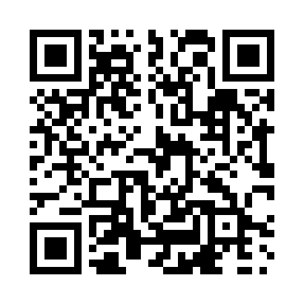
Prayer times for Boisville, Quebec, Canada
Wed 1 May 2024 - Fri 31 May 2024
High Latitude Method: Angle Based Rule
Prayer Calculation Method: Islamic Society of North America
Asar Calculation Method: Hanafi

Date | Day | Fajr | Sunrise | Dhuhr | Asr | Maghrib | Isha
1 | Wed | 4:09 | 5:50 | 1:05 | 6:08 | 8:20 | 10:01
2 | Thu | 4:07 | 5:49 | 1:05 | 6:09 | 8:21 | 10:03
3 | Fri | 4:05 | 5:47 | 1:05 | 6:09 | 8:23 | 10:05
4 | Sat | 4:03 | 5:46 | 1:04 | 6:10 | 8:24 | 10:07
5 | Sun | 4:00 | 5:44 | 1:04 | 6:11 | 8:25 | 10:09
6 | Mon | 3:58 | 5:43 | 1:04 | 6:12 | 8:27 | 10:11
7 | Tue | 3:56 | 5:41 | 1:04 | 6:13 | 8:28 | 10:14
8 | Wed | 3:54 | 5:40 | 1:04 | 6:13 | 8:29 | 10:16
9 | Thu | 3:52 | 5:38 | 1:04 | 6:14 | 8:31 | 10:18
10 | Fri | 3:50 | 5:37 | 1:04 | 6:15 | 8:32 | 10:20
11 | Sat | 3:48 | 5:36 | 1:04 | 6:16 | 8:33 | 10:22
12 | Sun | 3:46 | 5:34 | 1:04 | 6:16 | 8:35 | 10:24
13 | Mon | 3:44 | 5:33 | 1:04 | 6:17 | 8:36 | 10:26
14 | Tue | 3:41 | 5:32 | 1:04 | 6:18 | 8:37 | 10:28
15 | Wed | 3:39 | 5:30 | 1:04 | 6:19 | 8:38 | 10:30
16 | Thu | 3:38 | 5:29 | 1:04 | 6:19 | 8:40 | 10:32
17 | Fri | 3:36 | 5:28 | 1:04 | 6:20 | 8:41 | 10:34
18 | Sat | 3:34 | 5:27 | 1:04 | 6:21 | 8:42 | 10:36
19 | Sun | 3:32 | 5:26 | 1:04 | 6:22 | 8:43 | 10:38
20 | Mon | 3:30 | 5:25 | 1:04 | 6:22 | 8:44 | 10:40
21 | Tue | 3:28 | 5:24 | 1:04 | 6:23 | 8:46 | 10:42
22 | Wed | 3:26 | 5:23 | 1:04 | 6:24 | 8:47 | 10:44
23 | Thu | 3:25 | 5:22 | 1:05 | 6:24 | 8:48 | 10:46
24 | Fri | 3:23 | 5:21 | 1:05 | 6:25 | 8:49 | 10:47
25 | Sat | 3:21 | 5:20 | 1:05 | 6:26 | 8:50 | 10:49
26 | Sun | 3:19 | 5:19 | 1:05 | 6:26 | 8:51 | 10:51
27 | Mon | 3:18 | 5:18 | 1:05 | 6:27 | 8:52 | 10:53
28 | Tue | 3:16 | 5:17 | 1:05 | 6:28 | 8:53 | 10:55
29 | Wed | 3:15 | 5:17 | 1:05 | 6:28 | 8:54 | 10:56
30 | Thu | 3:13 | 5:16 | 1:05 | 6:29 | 8:55 | 10:58
31 | Fri | 3:12 | 5:15 | 1:06 | 6:29 | 8:56 | 11:00
Prayer times provided by https://www.salahtimes.com

