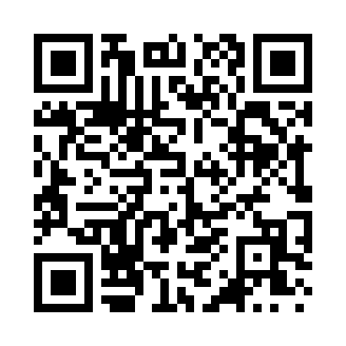
Prayer times for Cravat, Illinois, USA
Mon 1 Apr 2024 - Tue 30 Apr 2024
High Latitude Method: Angle Based Rule
Prayer Calculation Method: Islamic Society of North America
Asar Calculation Method: Shafi

Date | Day | Fajr | Sunrise | Dhuhr | Asr | Maghrib | Isha
1 | Mon | 5:26 | 6:40 | 1:00 | 4:35 | 7:20 | 8:35
2 | Tue | 5:24 | 6:39 | 1:00 | 4:35 | 7:21 | 8:36
3 | Wed | 5:23 | 6:37 | 12:59 | 4:35 | 7:22 | 8:37
4 | Thu | 5:21 | 6:36 | 12:59 | 4:36 | 7:23 | 8:38
5 | Fri | 5:19 | 6:34 | 12:59 | 4:36 | 7:24 | 8:39
6 | Sat | 5:18 | 6:33 | 12:59 | 4:36 | 7:25 | 8:40
7 | Sun | 5:16 | 6:31 | 12:58 | 4:37 | 7:26 | 8:41
8 | Mon | 5:14 | 6:30 | 12:58 | 4:37 | 7:27 | 8:42
9 | Tue | 5:13 | 6:28 | 12:58 | 4:37 | 7:28 | 8:44
10 | Wed | 5:11 | 6:27 | 12:57 | 4:37 | 7:29 | 8:45
11 | Thu | 5:09 | 6:25 | 12:57 | 4:38 | 7:30 | 8:46
12 | Fri | 5:08 | 6:24 | 12:57 | 4:38 | 7:31 | 8:47
13 | Sat | 5:06 | 6:22 | 12:57 | 4:38 | 7:32 | 8:48
14 | Sun | 5:04 | 6:21 | 12:56 | 4:38 | 7:33 | 8:49
15 | Mon | 5:03 | 6:20 | 12:56 | 4:39 | 7:33 | 8:51
16 | Tue | 5:01 | 6:18 | 12:56 | 4:39 | 7:34 | 8:52
17 | Wed | 4:59 | 6:17 | 12:56 | 4:39 | 7:35 | 8:53
18 | Thu | 4:58 | 6:15 | 12:56 | 4:39 | 7:36 | 8:54
19 | Fri | 4:56 | 6:14 | 12:55 | 4:40 | 7:37 | 8:55
20 | Sat | 4:54 | 6:13 | 12:55 | 4:40 | 7:38 | 8:57
21 | Sun | 4:53 | 6:11 | 12:55 | 4:40 | 7:39 | 8:58
22 | Mon | 4:51 | 6:10 | 12:55 | 4:40 | 7:40 | 8:59
23 | Tue | 4:50 | 6:09 | 12:55 | 4:40 | 7:41 | 9:00
24 | Wed | 4:48 | 6:07 | 12:54 | 4:41 | 7:42 | 9:01
25 | Thu | 4:47 | 6:06 | 12:54 | 4:41 | 7:43 | 9:03
26 | Fri | 4:45 | 6:05 | 12:54 | 4:41 | 7:44 | 9:04
27 | Sat | 4:43 | 6:04 | 12:54 | 4:41 | 7:45 | 9:05
28 | Sun | 4:42 | 6:02 | 12:54 | 4:41 | 7:46 | 9:06
29 | Mon | 4:40 | 6:01 | 12:54 | 4:42 | 7:47 | 9:08
30 | Tue | 4:39 | 6:00 | 12:54 | 4:42 | 7:48 | 9:09
Prayer times provided by https://www.salahtimes.com

