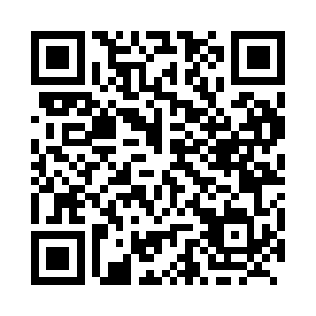
Prayer times for Billings, British Columbia, Canada
Mon 1 Apr 2024 - Tue 30 Apr 2024
High Latitude Method: Angle Based Rule
Prayer Calculation Method: Islamic Society of North America
Asar Calculation Method: Hanafi

Date | Day | Fajr | Sunrise | Dhuhr | Asr | Maghrib | Isha
1 | Mon | 4:58 | 6:29 | 12:57 | 5:25 | 7:25 | 8:56
2 | Tue | 4:56 | 6:27 | 12:56 | 5:26 | 7:27 | 8:58
3 | Wed | 4:53 | 6:25 | 12:56 | 5:27 | 7:28 | 9:00
4 | Thu | 4:51 | 6:23 | 12:56 | 5:28 | 7:30 | 9:02
5 | Fri | 4:49 | 6:21 | 12:55 | 5:29 | 7:31 | 9:03
6 | Sat | 4:46 | 6:19 | 12:55 | 5:30 | 7:33 | 9:05
7 | Sun | 4:44 | 6:17 | 12:55 | 5:32 | 7:34 | 9:07
8 | Mon | 4:41 | 6:14 | 12:55 | 5:33 | 7:36 | 9:09
9 | Tue | 4:39 | 6:12 | 12:54 | 5:34 | 7:37 | 9:11
10 | Wed | 4:36 | 6:10 | 12:54 | 5:35 | 7:39 | 9:13
11 | Thu | 4:34 | 6:08 | 12:54 | 5:36 | 7:40 | 9:15
12 | Fri | 4:31 | 6:06 | 12:54 | 5:37 | 7:42 | 9:17
13 | Sat | 4:29 | 6:04 | 12:53 | 5:38 | 7:43 | 9:19
14 | Sun | 4:26 | 6:02 | 12:53 | 5:39 | 7:45 | 9:21
15 | Mon | 4:24 | 6:00 | 12:53 | 5:40 | 7:46 | 9:23
16 | Tue | 4:21 | 5:58 | 12:53 | 5:41 | 7:48 | 9:25
17 | Wed | 4:19 | 5:56 | 12:52 | 5:42 | 7:49 | 9:27
18 | Thu | 4:16 | 5:55 | 12:52 | 5:43 | 7:51 | 9:29
19 | Fri | 4:14 | 5:53 | 12:52 | 5:44 | 7:52 | 9:31
20 | Sat | 4:12 | 5:51 | 12:52 | 5:45 | 7:54 | 9:33
21 | Sun | 4:09 | 5:49 | 12:51 | 5:46 | 7:55 | 9:35
22 | Mon | 4:07 | 5:47 | 12:51 | 5:46 | 7:57 | 9:37
23 | Tue | 4:04 | 5:45 | 12:51 | 5:47 | 7:58 | 9:39
24 | Wed | 4:02 | 5:43 | 12:51 | 5:48 | 8:00 | 9:42
25 | Thu | 3:59 | 5:41 | 12:51 | 5:49 | 8:01 | 9:44
26 | Fri | 3:57 | 5:40 | 12:51 | 5:50 | 8:03 | 9:46
27 | Sat | 3:54 | 5:38 | 12:50 | 5:51 | 8:04 | 9:48
28 | Sun | 3:52 | 5:36 | 12:50 | 5:52 | 8:05 | 9:50
29 | Mon | 3:49 | 5:34 | 12:50 | 5:53 | 8:07 | 9:52
30 | Tue | 3:47 | 5:33 | 12:50 | 5:54 | 8:08 | 9:55
Prayer times provided by https://www.salahtimes.com

