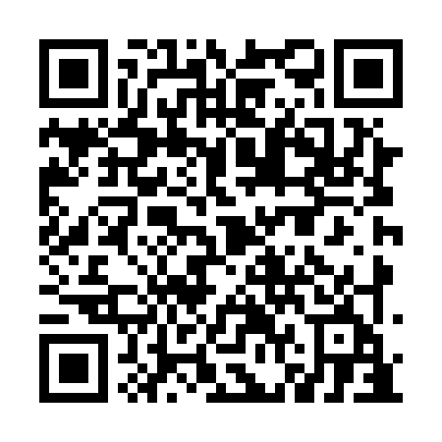
Prayer times for Bates Settlement, New Brunswick, Canada
Wed 1 May 2024 - Fri 31 May 2024
High Latitude Method: Angle Based Rule
Prayer Calculation Method: Islamic Society of North America
Asar Calculation Method: Hanafi

Date | Day | Fajr | Sunrise | Dhuhr | Asr | Maghrib | Isha
1 | Wed | 4:38 | 6:15 | 1:26 | 6:28 | 8:38 | 10:15
2 | Thu | 4:36 | 6:14 | 1:26 | 6:29 | 8:39 | 10:17
3 | Fri | 4:34 | 6:12 | 1:26 | 6:29 | 8:41 | 10:19
4 | Sat | 4:32 | 6:11 | 1:26 | 6:30 | 8:42 | 10:21
5 | Sun | 4:30 | 6:09 | 1:26 | 6:31 | 8:43 | 10:23
6 | Mon | 4:28 | 6:08 | 1:26 | 6:32 | 8:44 | 10:25
7 | Tue | 4:26 | 6:07 | 1:26 | 6:32 | 8:46 | 10:27
8 | Wed | 4:24 | 6:05 | 1:26 | 6:33 | 8:47 | 10:28
9 | Thu | 4:22 | 6:04 | 1:26 | 6:34 | 8:48 | 10:30
10 | Fri | 4:20 | 6:03 | 1:26 | 6:35 | 8:49 | 10:32
11 | Sat | 4:18 | 6:01 | 1:26 | 6:35 | 8:51 | 10:34
12 | Sun | 4:16 | 6:00 | 1:26 | 6:36 | 8:52 | 10:36
13 | Mon | 4:15 | 5:59 | 1:26 | 6:37 | 8:53 | 10:38
14 | Tue | 4:13 | 5:58 | 1:26 | 6:37 | 8:54 | 10:40
15 | Wed | 4:11 | 5:56 | 1:26 | 6:38 | 8:55 | 10:41
16 | Thu | 4:09 | 5:55 | 1:26 | 6:39 | 8:57 | 10:43
17 | Fri | 4:07 | 5:54 | 1:26 | 6:40 | 8:58 | 10:45
18 | Sat | 4:06 | 5:53 | 1:26 | 6:40 | 8:59 | 10:47
19 | Sun | 4:04 | 5:52 | 1:26 | 6:41 | 9:00 | 10:49
20 | Mon | 4:02 | 5:51 | 1:26 | 6:42 | 9:01 | 10:50
21 | Tue | 4:01 | 5:50 | 1:26 | 6:42 | 9:02 | 10:52
22 | Wed | 3:59 | 5:49 | 1:26 | 6:43 | 9:03 | 10:54
23 | Thu | 3:57 | 5:48 | 1:26 | 6:44 | 9:04 | 10:56
24 | Fri | 3:56 | 5:47 | 1:26 | 6:44 | 9:06 | 10:57
25 | Sat | 3:54 | 5:47 | 1:26 | 6:45 | 9:07 | 10:59
26 | Sun | 3:53 | 5:46 | 1:26 | 6:45 | 9:08 | 11:01
27 | Mon | 3:52 | 5:45 | 1:27 | 6:46 | 9:09 | 11:02
28 | Tue | 3:50 | 5:44 | 1:27 | 6:47 | 9:10 | 11:04
29 | Wed | 3:49 | 5:44 | 1:27 | 6:47 | 9:10 | 11:05
30 | Thu | 3:48 | 5:43 | 1:27 | 6:48 | 9:11 | 11:07
31 | Fri | 3:47 | 5:42 | 1:27 | 6:48 | 9:12 | 11:08
Prayer times provided by https://www.salahtimes.com

