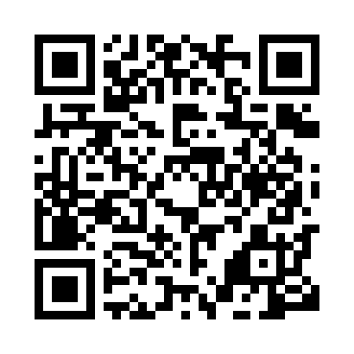
Prayer times for Bombi, Cameroon
Wed 1 May 2024 - Fri 31 May 2024
High Latitude Method: None
Prayer Calculation Method: Muslim World League
Asar Calculation Method: Shafi

Date | Day | Fajr | Sunrise | Dhuhr | Asr | Maghrib | Isha
1 | Wed | 4:42 | 5:54 | 12:03 | 3:22 | 6:12 | 7:20
2 | Thu | 4:42 | 5:54 | 12:03 | 3:22 | 6:12 | 7:20
3 | Fri | 4:42 | 5:54 | 12:03 | 3:22 | 6:12 | 7:20
4 | Sat | 4:41 | 5:54 | 12:03 | 3:22 | 6:12 | 7:20
5 | Sun | 4:41 | 5:53 | 12:03 | 3:23 | 6:12 | 7:20
6 | Mon | 4:41 | 5:53 | 12:03 | 3:23 | 6:12 | 7:20
7 | Tue | 4:41 | 5:53 | 12:03 | 3:23 | 6:12 | 7:21
8 | Wed | 4:40 | 5:53 | 12:03 | 3:23 | 6:12 | 7:21
9 | Thu | 4:40 | 5:53 | 12:03 | 3:24 | 6:12 | 7:21
10 | Fri | 4:40 | 5:53 | 12:02 | 3:24 | 6:12 | 7:21
11 | Sat | 4:39 | 5:53 | 12:02 | 3:24 | 6:12 | 7:21
12 | Sun | 4:39 | 5:52 | 12:02 | 3:25 | 6:13 | 7:21
13 | Mon | 4:39 | 5:52 | 12:02 | 3:25 | 6:13 | 7:22
14 | Tue | 4:39 | 5:52 | 12:02 | 3:25 | 6:13 | 7:22
15 | Wed | 4:39 | 5:52 | 12:02 | 3:25 | 6:13 | 7:22
16 | Thu | 4:38 | 5:52 | 12:02 | 3:26 | 6:13 | 7:22
17 | Fri | 4:38 | 5:52 | 12:02 | 3:26 | 6:13 | 7:23
18 | Sat | 4:38 | 5:52 | 12:03 | 3:26 | 6:13 | 7:23
19 | Sun | 4:38 | 5:52 | 12:03 | 3:26 | 6:13 | 7:23
20 | Mon | 4:38 | 5:52 | 12:03 | 3:27 | 6:13 | 7:23
21 | Tue | 4:38 | 5:52 | 12:03 | 3:27 | 6:14 | 7:23
22 | Wed | 4:38 | 5:52 | 12:03 | 3:27 | 6:14 | 7:24
23 | Thu | 4:37 | 5:52 | 12:03 | 3:28 | 6:14 | 7:24
24 | Fri | 4:37 | 5:52 | 12:03 | 3:28 | 6:14 | 7:24
25 | Sat | 4:37 | 5:52 | 12:03 | 3:28 | 6:14 | 7:25
26 | Sun | 4:37 | 5:52 | 12:03 | 3:28 | 6:15 | 7:25
27 | Mon | 4:37 | 5:52 | 12:03 | 3:29 | 6:15 | 7:25
28 | Tue | 4:37 | 5:52 | 12:03 | 3:29 | 6:15 | 7:25
29 | Wed | 4:37 | 5:52 | 12:04 | 3:29 | 6:15 | 7:26
30 | Thu | 4:37 | 5:52 | 12:04 | 3:29 | 6:15 | 7:26
31 | Fri | 4:37 | 5:52 | 12:04 | 3:30 | 6:16 | 7:26
Prayer times provided by https://www.salahtimes.com

