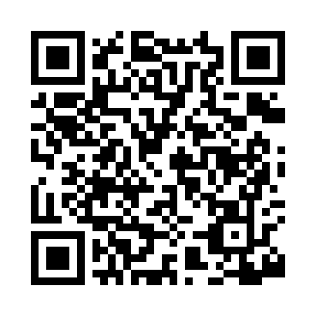
Prayer times for Balko, Oklahoma, USA
Wed 1 May 2024 - Fri 31 May 2024
High Latitude Method: Angle Based Rule
Prayer Calculation Method: Islamic Society of North America
Asar Calculation Method: Shafi

Date | Day | Fajr | Sunrise | Dhuhr | Asr | Maghrib | Isha
1 | Wed | 5:30 | 6:48 | 1:40 | 5:26 | 8:32 | 9:51
2 | Thu | 5:28 | 6:47 | 1:40 | 5:26 | 8:33 | 9:52
3 | Fri | 5:27 | 6:46 | 1:40 | 5:26 | 8:33 | 9:53
4 | Sat | 5:26 | 6:45 | 1:39 | 5:27 | 8:34 | 9:54
5 | Sun | 5:24 | 6:44 | 1:39 | 5:27 | 8:35 | 9:55
6 | Mon | 5:23 | 6:43 | 1:39 | 5:27 | 8:36 | 9:56
7 | Tue | 5:22 | 6:42 | 1:39 | 5:27 | 8:37 | 9:57
8 | Wed | 5:20 | 6:41 | 1:39 | 5:27 | 8:38 | 9:59
9 | Thu | 5:19 | 6:40 | 1:39 | 5:27 | 8:39 | 10:00
10 | Fri | 5:18 | 6:39 | 1:39 | 5:27 | 8:39 | 10:01
11 | Sat | 5:17 | 6:38 | 1:39 | 5:28 | 8:40 | 10:02
12 | Sun | 5:16 | 6:38 | 1:39 | 5:28 | 8:41 | 10:03
13 | Mon | 5:14 | 6:37 | 1:39 | 5:28 | 8:42 | 10:04
14 | Tue | 5:13 | 6:36 | 1:39 | 5:28 | 8:43 | 10:05
15 | Wed | 5:12 | 6:35 | 1:39 | 5:28 | 8:44 | 10:07
16 | Thu | 5:11 | 6:34 | 1:39 | 5:28 | 8:44 | 10:08
17 | Fri | 5:10 | 6:34 | 1:39 | 5:29 | 8:45 | 10:09
18 | Sat | 5:09 | 6:33 | 1:39 | 5:29 | 8:46 | 10:10
19 | Sun | 5:08 | 6:32 | 1:39 | 5:29 | 8:47 | 10:11
20 | Mon | 5:07 | 6:31 | 1:39 | 5:29 | 8:48 | 10:12
21 | Tue | 5:06 | 6:31 | 1:39 | 5:29 | 8:48 | 10:13
22 | Wed | 5:05 | 6:30 | 1:39 | 5:30 | 8:49 | 10:14
23 | Thu | 5:04 | 6:30 | 1:40 | 5:30 | 8:50 | 10:15
24 | Fri | 5:04 | 6:29 | 1:40 | 5:30 | 8:51 | 10:16
25 | Sat | 5:03 | 6:28 | 1:40 | 5:30 | 8:51 | 10:17
26 | Sun | 5:02 | 6:28 | 1:40 | 5:30 | 8:52 | 10:18
27 | Mon | 5:01 | 6:27 | 1:40 | 5:30 | 8:53 | 10:19
28 | Tue | 5:01 | 6:27 | 1:40 | 5:31 | 8:54 | 10:20
29 | Wed | 5:00 | 6:27 | 1:40 | 5:31 | 8:54 | 10:21
30 | Thu | 4:59 | 6:26 | 1:40 | 5:31 | 8:55 | 10:22
31 | Fri | 4:59 | 6:26 | 1:41 | 5:31 | 8:56 | 10:23
Prayer times provided by https://www.salahtimes.com

