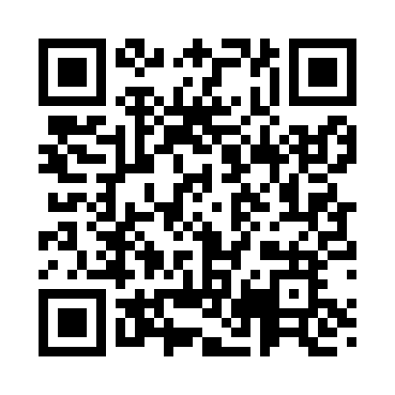

**Prayer times for Abjaku, Estonia**

**Sun 1 Sep 2024 - Mon 30 Sep 2024**

**High Latitude Method: Angle Based Rule**

**Prayer Calculation Method: Muslim World League**

**Asar Calculation Method: Hanafi**

|  |  |  |  |  |  |  |  |
| --- | --- | --- | --- | --- | --- | --- | --- |
| **Date** | **Day** | **Fajr** | **Sunrise** | **Dhuhr** | **Asr** | **Maghrib** | **Isha** |
| 1 | Sun | 3:38 | 6:19 | 1:18 | 5:58 | 8:17 | 10:44 |
| 2 | Mon | 3:42 | 6:21 | 1:18 | 5:56 | 8:14 | 10:40 |
| 3 | Tue | 3:46 | 6:23 | 1:18 | 5:53 | 8:11 | 10:36 |
| 4 | Wed | 3:50 | 6:25 | 1:17 | 5:51 | 8:08 | 10:32 |
| 5 | Thu | 3:53 | 6:28 | 1:17 | 5:49 | 8:05 | 10:28 |
| 6 | Fri | 3:57 | 6:30 | 1:17 | 5:47 | 8:03 | 10:23 |
| 7 | Sat | 4:01 | 6:32 | 1:16 | 5:45 | 8:00 | 10:19 |
| 8 | Sun | 4:04 | 6:34 | 1:16 | 5:42 | 7:57 | 10:16 |
| 9 | Mon | 4:08 | 6:36 | 1:16 | 5:40 | 7:54 | 10:12 |
| 10 | Tue | 4:11 | 6:38 | 1:15 | 5:38 | 7:51 | 10:08 |
| 11 | Wed | 4:14 | 6:40 | 1:15 | 5:36 | 7:48 | 10:04 |
| 12 | Thu | 4:17 | 6:43 | 1:15 | 5:33 | 7:46 | 10:00 |
| 13 | Fri | 4:20 | 6:45 | 1:14 | 5:31 | 7:43 | 9:57 |
| 14 | Sat | 4:24 | 6:47 | 1:14 | 5:29 | 7:40 | 9:53 |
| 15 | Sun | 4:27 | 6:49 | 1:14 | 5:26 | 7:37 | 9:49 |
| 16 | Mon | 4:30 | 6:51 | 1:13 | 5:24 | 7:34 | 9:46 |
| 17 | Tue | 4:33 | 6:53 | 1:13 | 5:22 | 7:31 | 9:42 |
| 18 | Wed | 4:36 | 6:55 | 1:13 | 5:19 | 7:28 | 9:39 |
| 19 | Thu | 4:38 | 6:58 | 1:12 | 5:17 | 7:26 | 9:35 |
| 20 | Fri | 4:41 | 7:00 | 1:12 | 5:15 | 7:23 | 9:32 |
| 21 | Sat | 4:44 | 7:02 | 1:11 | 5:12 | 7:20 | 9:28 |
| 22 | Sun | 4:47 | 7:04 | 1:11 | 5:10 | 7:17 | 9:25 |
| 23 | Mon | 4:50 | 7:06 | 1:11 | 5:07 | 7:14 | 9:22 |
| 24 | Tue | 4:52 | 7:08 | 1:10 | 5:05 | 7:11 | 9:18 |
| 25 | Wed | 4:55 | 7:10 | 1:10 | 5:02 | 7:08 | 9:15 |
| 26 | Thu | 4:58 | 7:13 | 1:10 | 5:00 | 7:06 | 9:12 |
| 27 | Fri | 5:00 | 7:15 | 1:09 | 4:58 | 7:03 | 9:09 |
| 28 | Sat | 5:03 | 7:17 | 1:09 | 4:55 | 7:00 | 9:05 |
| 29 | Sun | 5:05 | 7:19 | 1:09 | 4:53 | 6:57 | 9:02 |
| 30 | Mon | 5:08 | 7:21 | 1:08 | 4:50 | 6:54 | 8:59 |

**Prayer times provided by https://www.salahtimes.com**