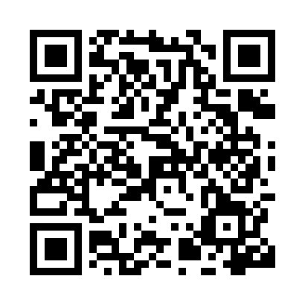
Prayer times for Kermt, Belgium
Mon 1 Apr 2024 - Tue 30 Apr 2024
High Latitude Method: Angle Based Rule
Prayer Calculation Method: Muslim World League
Asar Calculation Method: Shafi

Date | Day | Fajr | Sunrise | Dhuhr | Asr | Maghrib | Isha
1 | Mon | 5:17 | 7:14 | 1:43 | 5:16 | 8:12 | 10:02
2 | Tue | 5:14 | 7:12 | 1:42 | 5:17 | 8:14 | 10:04
3 | Wed | 5:12 | 7:10 | 1:42 | 5:18 | 8:16 | 10:07
4 | Thu | 5:09 | 7:07 | 1:42 | 5:19 | 8:17 | 10:09
5 | Fri | 5:06 | 7:05 | 1:42 | 5:20 | 8:19 | 10:11
6 | Sat | 5:03 | 7:03 | 1:41 | 5:20 | 8:21 | 10:13
7 | Sun | 5:00 | 7:01 | 1:41 | 5:21 | 8:22 | 10:15
8 | Mon | 4:57 | 6:59 | 1:41 | 5:22 | 8:24 | 10:18
9 | Tue | 4:54 | 6:56 | 1:40 | 5:23 | 8:25 | 10:20
10 | Wed | 4:52 | 6:54 | 1:40 | 5:24 | 8:27 | 10:22
11 | Thu | 4:49 | 6:52 | 1:40 | 5:24 | 8:29 | 10:24
12 | Fri | 4:46 | 6:50 | 1:40 | 5:25 | 8:30 | 10:27
13 | Sat | 4:43 | 6:48 | 1:39 | 5:26 | 8:32 | 10:29
14 | Sun | 4:40 | 6:46 | 1:39 | 5:27 | 8:34 | 10:31
15 | Mon | 4:37 | 6:44 | 1:39 | 5:27 | 8:35 | 10:34
16 | Tue | 4:34 | 6:41 | 1:39 | 5:28 | 8:37 | 10:36
17 | Wed | 4:31 | 6:39 | 1:38 | 5:29 | 8:39 | 10:39
18 | Thu | 4:28 | 6:37 | 1:38 | 5:30 | 8:40 | 10:41
19 | Fri | 4:25 | 6:35 | 1:38 | 5:30 | 8:42 | 10:44
20 | Sat | 4:22 | 6:33 | 1:38 | 5:31 | 8:43 | 10:46
21 | Sun | 4:18 | 6:31 | 1:38 | 5:32 | 8:45 | 10:49
22 | Mon | 4:15 | 6:29 | 1:37 | 5:32 | 8:47 | 10:52
23 | Tue | 4:12 | 6:27 | 1:37 | 5:33 | 8:48 | 10:54
24 | Wed | 4:09 | 6:25 | 1:37 | 5:34 | 8:50 | 10:57
25 | Thu | 4:06 | 6:23 | 1:37 | 5:35 | 8:52 | 11:00
26 | Fri | 4:03 | 6:21 | 1:37 | 5:35 | 8:53 | 11:02
27 | Sat | 3:59 | 6:19 | 1:37 | 5:36 | 8:55 | 11:05
28 | Sun | 3:56 | 6:17 | 1:36 | 5:37 | 8:56 | 11:08
29 | Mon | 3:53 | 6:16 | 1:36 | 5:37 | 8:58 | 11:11
30 | Tue | 3:49 | 6:14 | 1:36 | 5:38 | 9:00 | 11:14
Prayer times provided by https://www.salahtimes.com

