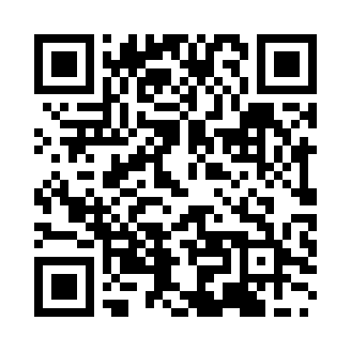
Prayer times for Obama, Japan
Wed 1 May 2024 - Fri 31 May 2024
High Latitude Method: None
Prayer Calculation Method: Muslim World League
Asar Calculation Method: Shafi

Date | Day | Fajr | Sunrise | Dhuhr | Asr | Maghrib | Isha
1 | Wed | 3:31 | 5:05 | 11:54 | 3:39 | 6:43 | 8:12
2 | Thu | 3:29 | 5:04 | 11:54 | 3:39 | 6:44 | 8:13
3 | Fri | 3:28 | 5:03 | 11:54 | 3:39 | 6:45 | 8:15
4 | Sat | 3:27 | 5:02 | 11:54 | 3:39 | 6:46 | 8:16
5 | Sun | 3:25 | 5:01 | 11:54 | 3:39 | 6:47 | 8:17
6 | Mon | 3:24 | 5:00 | 11:54 | 3:39 | 6:48 | 8:18
7 | Tue | 3:23 | 4:59 | 11:54 | 3:40 | 6:48 | 8:19
8 | Wed | 3:21 | 4:58 | 11:54 | 3:40 | 6:49 | 8:20
9 | Thu | 3:20 | 4:57 | 11:54 | 3:40 | 6:50 | 8:21
10 | Fri | 3:19 | 4:57 | 11:53 | 3:40 | 6:51 | 8:23
11 | Sat | 3:18 | 4:56 | 11:53 | 3:40 | 6:52 | 8:24
12 | Sun | 3:16 | 4:55 | 11:53 | 3:40 | 6:52 | 8:25
13 | Mon | 3:15 | 4:54 | 11:53 | 3:40 | 6:53 | 8:26
14 | Tue | 3:14 | 4:53 | 11:53 | 3:40 | 6:54 | 8:27
15 | Wed | 3:13 | 4:52 | 11:53 | 3:40 | 6:55 | 8:28
16 | Thu | 3:12 | 4:52 | 11:53 | 3:41 | 6:56 | 8:29
17 | Fri | 3:11 | 4:51 | 11:53 | 3:41 | 6:56 | 8:31
18 | Sat | 3:09 | 4:50 | 11:54 | 3:41 | 6:57 | 8:32
19 | Sun | 3:08 | 4:50 | 11:54 | 3:41 | 6:58 | 8:33
20 | Mon | 3:07 | 4:49 | 11:54 | 3:41 | 6:59 | 8:34
21 | Tue | 3:06 | 4:48 | 11:54 | 3:41 | 6:59 | 8:35
22 | Wed | 3:05 | 4:48 | 11:54 | 3:42 | 7:00 | 8:36
23 | Thu | 3:05 | 4:47 | 11:54 | 3:42 | 7:01 | 8:37
24 | Fri | 3:04 | 4:47 | 11:54 | 3:42 | 7:02 | 8:38
25 | Sat | 3:03 | 4:46 | 11:54 | 3:42 | 7:02 | 8:39
26 | Sun | 3:02 | 4:45 | 11:54 | 3:42 | 7:03 | 8:40
27 | Mon | 3:01 | 4:45 | 11:54 | 3:42 | 7:04 | 8:41
28 | Tue | 3:00 | 4:45 | 11:54 | 3:43 | 7:04 | 8:42
29 | Wed | 3:00 | 4:44 | 11:55 | 3:43 | 7:05 | 8:43
30 | Thu | 2:59 | 4:44 | 11:55 | 3:43 | 7:06 | 8:44
31 | Fri | 2:58 | 4:43 | 11:55 | 3:43 | 7:06 | 8:45
Prayer times provided by https://www.salahtimes.com

