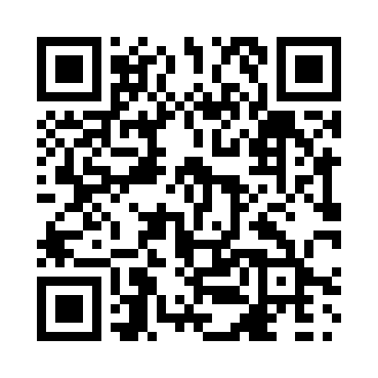
Prayer times for Bellshill, Alberta, Canada
Sat 1 Jun 2024 - Sun 30 Jun 2024
High Latitude Method: Angle Based Rule
Prayer Calculation Method: Islamic Society of North America
Asar Calculation Method: Hanafi

Date | Day | Fajr | Sunrise | Dhuhr | Asr | Maghrib | Isha
1 | Sat | 3:16 | 5:08 | 1:24 | 6:59 | 9:40 | 11:32
2 | Sun | 3:16 | 5:08 | 1:24 | 7:00 | 9:41 | 11:33
3 | Mon | 3:16 | 5:07 | 1:24 | 7:01 | 9:42 | 11:34
4 | Tue | 3:15 | 5:06 | 1:25 | 7:01 | 9:43 | 11:34
5 | Wed | 3:15 | 5:05 | 1:25 | 7:02 | 9:44 | 11:35
6 | Thu | 3:15 | 5:05 | 1:25 | 7:02 | 9:45 | 11:35
7 | Fri | 3:15 | 5:04 | 1:25 | 7:03 | 9:46 | 11:36
8 | Sat | 3:15 | 5:04 | 1:25 | 7:04 | 9:47 | 11:36
9 | Sun | 3:15 | 5:04 | 1:26 | 7:04 | 9:48 | 11:37
10 | Mon | 3:15 | 5:03 | 1:26 | 7:05 | 9:49 | 11:37
11 | Tue | 3:14 | 5:03 | 1:26 | 7:05 | 9:49 | 11:38
12 | Wed | 3:14 | 5:03 | 1:26 | 7:05 | 9:50 | 11:38
13 | Thu | 3:14 | 5:02 | 1:26 | 7:06 | 9:51 | 11:39
14 | Fri | 3:14 | 5:02 | 1:27 | 7:06 | 9:51 | 11:39
15 | Sat | 3:14 | 5:02 | 1:27 | 7:07 | 9:52 | 11:39
16 | Sun | 3:15 | 5:02 | 1:27 | 7:07 | 9:52 | 11:40
17 | Mon | 3:15 | 5:02 | 1:27 | 7:07 | 9:52 | 11:40
18 | Tue | 3:15 | 5:02 | 1:27 | 7:08 | 9:53 | 11:40
19 | Wed | 3:15 | 5:02 | 1:28 | 7:08 | 9:53 | 11:40
20 | Thu | 3:15 | 5:02 | 1:28 | 7:08 | 9:53 | 11:41
21 | Fri | 3:15 | 5:03 | 1:28 | 7:08 | 9:53 | 11:41
22 | Sat | 3:16 | 5:03 | 1:28 | 7:08 | 9:54 | 11:41
23 | Sun | 3:16 | 5:03 | 1:29 | 7:09 | 9:54 | 11:41
24 | Mon | 3:16 | 5:04 | 1:29 | 7:09 | 9:54 | 11:41
25 | Tue | 3:17 | 5:04 | 1:29 | 7:09 | 9:54 | 11:41
26 | Wed | 3:17 | 5:05 | 1:29 | 7:09 | 9:54 | 11:41
27 | Thu | 3:17 | 5:05 | 1:29 | 7:09 | 9:53 | 11:41
28 | Fri | 3:18 | 5:06 | 1:30 | 7:09 | 9:53 | 11:41
29 | Sat | 3:18 | 5:06 | 1:30 | 7:09 | 9:53 | 11:41
30 | Sun | 3:18 | 5:07 | 1:30 | 7:09 | 9:53 | 11:41
Prayer times provided by https://www.salahtimes.com

