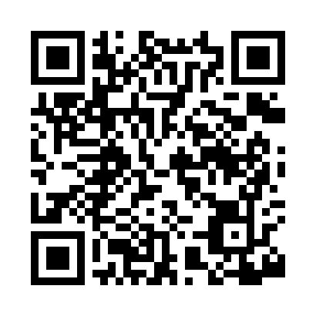
Prayer times for Barre, Massachusetts, USA
Wed 1 May 2024 - Fri 31 May 2024
High Latitude Method: Angle Based Rule
Prayer Calculation Method: Islamic Society of North America
Asar Calculation Method: Shafi

Date | Day | Fajr | Sunrise | Dhuhr | Asr | Maghrib | Isha
1 | Wed | 4:14 | 5:43 | 12:45 | 4:39 | 7:49 | 9:18
2 | Thu | 4:12 | 5:41 | 12:45 | 4:39 | 7:50 | 9:19
3 | Fri | 4:11 | 5:40 | 12:45 | 4:40 | 7:51 | 9:21
4 | Sat | 4:09 | 5:39 | 12:45 | 4:40 | 7:52 | 9:22
5 | Sun | 4:07 | 5:38 | 12:45 | 4:40 | 7:53 | 9:24
6 | Mon | 4:06 | 5:36 | 12:45 | 4:41 | 7:54 | 9:25
7 | Tue | 4:04 | 5:35 | 12:45 | 4:41 | 7:55 | 9:27
8 | Wed | 4:02 | 5:34 | 12:45 | 4:41 | 7:56 | 9:28
9 | Thu | 4:01 | 5:33 | 12:45 | 4:42 | 7:58 | 9:30
10 | Fri | 3:59 | 5:32 | 12:45 | 4:42 | 7:59 | 9:31
11 | Sat | 3:58 | 5:30 | 12:45 | 4:42 | 8:00 | 9:33
12 | Sun | 3:56 | 5:29 | 12:45 | 4:43 | 8:01 | 9:34
13 | Mon | 3:54 | 5:28 | 12:45 | 4:43 | 8:02 | 9:36
14 | Tue | 3:53 | 5:27 | 12:45 | 4:43 | 8:03 | 9:37
15 | Wed | 3:52 | 5:26 | 12:45 | 4:44 | 8:04 | 9:39
16 | Thu | 3:50 | 5:25 | 12:45 | 4:44 | 8:05 | 9:40
17 | Fri | 3:49 | 5:24 | 12:45 | 4:44 | 8:06 | 9:42
18 | Sat | 3:47 | 5:23 | 12:45 | 4:45 | 8:07 | 9:43
19 | Sun | 3:46 | 5:22 | 12:45 | 4:45 | 8:08 | 9:45
20 | Mon | 3:45 | 5:22 | 12:45 | 4:45 | 8:09 | 9:46
21 | Tue | 3:43 | 5:21 | 12:45 | 4:45 | 8:10 | 9:48
22 | Wed | 3:42 | 5:20 | 12:45 | 4:46 | 8:11 | 9:49
23 | Thu | 3:41 | 5:19 | 12:45 | 4:46 | 8:12 | 9:50
24 | Fri | 3:40 | 5:18 | 12:45 | 4:46 | 8:13 | 9:52
25 | Sat | 3:39 | 5:18 | 12:45 | 4:47 | 8:14 | 9:53
26 | Sun | 3:38 | 5:17 | 12:46 | 4:47 | 8:14 | 9:54
27 | Mon | 3:36 | 5:16 | 12:46 | 4:47 | 8:15 | 9:56
28 | Tue | 3:35 | 5:16 | 12:46 | 4:48 | 8:16 | 9:57
29 | Wed | 3:34 | 5:15 | 12:46 | 4:48 | 8:17 | 9:58
30 | Thu | 3:34 | 5:15 | 12:46 | 4:48 | 8:18 | 9:59
31 | Fri | 3:33 | 5:14 | 12:46 | 4:49 | 8:19 | 10:00
Prayer times provided by https://www.salahtimes.com

