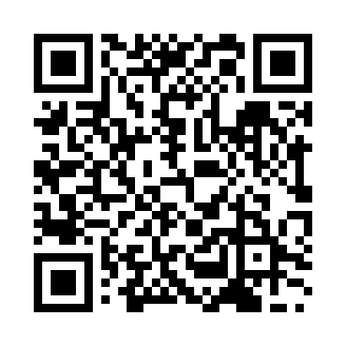
Prayer times for Nakashibetsu, Japan
Wed 1 May 2024 - Fri 31 May 2024
High Latitude Method: None
Prayer Calculation Method: Muslim World League
Asar Calculation Method: Shafi

Date | Day | Fajr | Sunrise | Dhuhr | Asr | Maghrib | Isha
1 | Wed | 2:20 | 4:13 | 11:17 | 3:12 | 6:22 | 8:08
2 | Thu | 2:18 | 4:11 | 11:17 | 3:12 | 6:23 | 8:10
3 | Fri | 2:16 | 4:10 | 11:17 | 3:13 | 6:25 | 8:11
4 | Sat | 2:14 | 4:09 | 11:17 | 3:13 | 6:26 | 8:13
5 | Sun | 2:12 | 4:07 | 11:17 | 3:13 | 6:27 | 8:15
6 | Mon | 2:10 | 4:06 | 11:17 | 3:14 | 6:28 | 8:17
7 | Tue | 2:08 | 4:05 | 11:17 | 3:14 | 6:29 | 8:18
8 | Wed | 2:06 | 4:03 | 11:17 | 3:14 | 6:30 | 8:20
9 | Thu | 2:04 | 4:02 | 11:17 | 3:15 | 6:32 | 8:22
10 | Fri | 2:02 | 4:01 | 11:17 | 3:15 | 6:33 | 8:24
11 | Sat | 2:00 | 4:00 | 11:17 | 3:15 | 6:34 | 8:25
12 | Sun | 1:58 | 3:59 | 11:17 | 3:16 | 6:35 | 8:27
13 | Mon | 1:57 | 3:58 | 11:16 | 3:16 | 6:36 | 8:29
14 | Tue | 1:55 | 3:56 | 11:16 | 3:16 | 6:37 | 8:31
15 | Wed | 1:53 | 3:55 | 11:17 | 3:17 | 6:38 | 8:32
16 | Thu | 1:51 | 3:54 | 11:17 | 3:17 | 6:39 | 8:34
17 | Fri | 1:49 | 3:53 | 11:17 | 3:18 | 6:40 | 8:36
18 | Sat | 1:48 | 3:52 | 11:17 | 3:18 | 6:41 | 8:37
19 | Sun | 1:46 | 3:51 | 11:17 | 3:18 | 6:42 | 8:39
20 | Mon | 1:44 | 3:50 | 11:17 | 3:19 | 6:43 | 8:41
21 | Tue | 1:43 | 3:50 | 11:17 | 3:19 | 6:44 | 8:43
22 | Wed | 1:41 | 3:49 | 11:17 | 3:19 | 6:45 | 8:44
23 | Thu | 1:39 | 3:48 | 11:17 | 3:20 | 6:46 | 8:46
24 | Fri | 1:38 | 3:47 | 11:17 | 3:20 | 6:47 | 8:47
25 | Sat | 1:36 | 3:46 | 11:17 | 3:20 | 6:48 | 8:49
26 | Sun | 1:35 | 3:46 | 11:17 | 3:21 | 6:49 | 8:51
27 | Mon | 1:34 | 3:45 | 11:17 | 3:21 | 6:50 | 8:52
28 | Tue | 1:32 | 3:44 | 11:17 | 3:21 | 6:51 | 8:54
29 | Wed | 1:31 | 3:44 | 11:18 | 3:22 | 6:52 | 8:55
30 | Thu | 1:30 | 3:43 | 11:18 | 3:22 | 6:53 | 8:57
31 | Fri | 1:28 | 3:42 | 11:18 | 3:22 | 6:54 | 8:58
Prayer times provided by https://www.salahtimes.com

