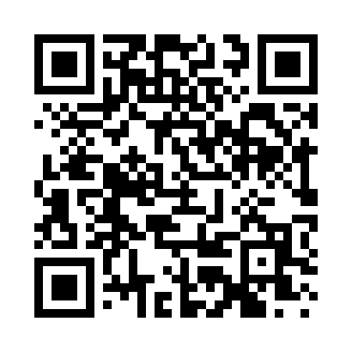
Prayer times for Northwoods Club, New York, USA
Mon 1 Jul 2024 - Wed 31 Jul 2024
High Latitude Method: Angle Based Rule
Prayer Calculation Method: Islamic Society of North America
Asar Calculation Method: Shafi

Date | Day | Fajr | Sunrise | Dhuhr | Asr | Maghrib | Isha
1 | Mon | 3:28 | 5:19 | 1:01 | 5:07 | 8:43 | 10:32
2 | Tue | 3:29 | 5:19 | 1:01 | 5:07 | 8:42 | 10:32
3 | Wed | 3:30 | 5:20 | 1:01 | 5:07 | 8:42 | 10:31
4 | Thu | 3:31 | 5:20 | 1:01 | 5:07 | 8:42 | 10:31
5 | Fri | 3:32 | 5:21 | 1:01 | 5:07 | 8:41 | 10:30
6 | Sat | 3:33 | 5:22 | 1:01 | 5:07 | 8:41 | 10:29
7 | Sun | 3:34 | 5:22 | 1:02 | 5:07 | 8:41 | 10:29
8 | Mon | 3:35 | 5:23 | 1:02 | 5:07 | 8:40 | 10:28
9 | Tue | 3:36 | 5:24 | 1:02 | 5:07 | 8:40 | 10:27
10 | Wed | 3:38 | 5:25 | 1:02 | 5:07 | 8:39 | 10:26
11 | Thu | 3:39 | 5:25 | 1:02 | 5:07 | 8:39 | 10:25
12 | Fri | 3:40 | 5:26 | 1:02 | 5:07 | 8:38 | 10:24
13 | Sat | 3:41 | 5:27 | 1:02 | 5:07 | 8:37 | 10:23
14 | Sun | 3:43 | 5:28 | 1:03 | 5:07 | 8:37 | 10:22
15 | Mon | 3:44 | 5:29 | 1:03 | 5:07 | 8:36 | 10:21
16 | Tue | 3:45 | 5:30 | 1:03 | 5:07 | 8:35 | 10:19
17 | Wed | 3:47 | 5:31 | 1:03 | 5:07 | 8:35 | 10:18
18 | Thu | 3:48 | 5:32 | 1:03 | 5:06 | 8:34 | 10:17
19 | Fri | 3:50 | 5:32 | 1:03 | 5:06 | 8:33 | 10:15
20 | Sat | 3:51 | 5:33 | 1:03 | 5:06 | 8:32 | 10:14
21 | Sun | 3:53 | 5:34 | 1:03 | 5:06 | 8:31 | 10:13
22 | Mon | 3:54 | 5:35 | 1:03 | 5:05 | 8:30 | 10:11
23 | Tue | 3:56 | 5:36 | 1:03 | 5:05 | 8:29 | 10:10
24 | Wed | 3:57 | 5:37 | 1:03 | 5:05 | 8:28 | 10:08
25 | Thu | 3:59 | 5:38 | 1:03 | 5:05 | 8:27 | 10:07
26 | Fri | 4:00 | 5:39 | 1:03 | 5:04 | 8:26 | 10:05
27 | Sat | 4:02 | 5:41 | 1:03 | 5:04 | 8:25 | 10:04
28 | Sun | 4:03 | 5:42 | 1:03 | 5:04 | 8:24 | 10:02
29 | Mon | 4:05 | 5:43 | 1:03 | 5:03 | 8:23 | 10:00
30 | Tue | 4:06 | 5:44 | 1:03 | 5:03 | 8:22 | 9:59
31 | Wed | 4:08 | 5:45 | 1:03 | 5:02 | 8:21 | 9:57
Prayer times provided by https://www.salahtimes.com

