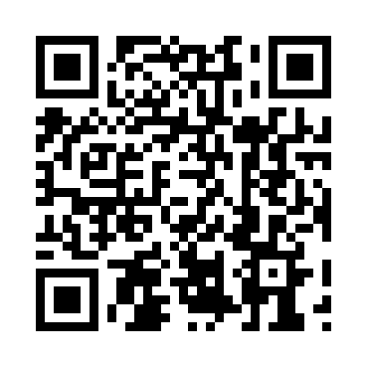
Prayer times for Bickerdike, Alberta, Canada
Wed 1 May 2024 - Fri 31 May 2024
High Latitude Method: Angle Based Rule
Prayer Calculation Method: Islamic Society of North America
Asar Calculation Method: Hanafi

Date | Day | Fajr | Sunrise | Dhuhr | Asr | Maghrib | Isha
1 | Wed | 4:02 | 6:10 | 1:44 | 6:54 | 9:18 | 11:27
2 | Thu | 3:59 | 6:08 | 1:43 | 6:55 | 9:20 | 11:30
3 | Fri | 3:55 | 6:06 | 1:43 | 6:56 | 9:22 | 11:33
4 | Sat | 3:54 | 6:04 | 1:43 | 6:57 | 9:23 | 11:34
5 | Sun | 3:53 | 6:02 | 1:43 | 6:58 | 9:25 | 11:34
6 | Mon | 3:52 | 6:00 | 1:43 | 6:59 | 9:27 | 11:35
7 | Tue | 3:51 | 5:59 | 1:43 | 7:00 | 9:29 | 11:36
8 | Wed | 3:50 | 5:57 | 1:43 | 7:01 | 9:30 | 11:37
9 | Thu | 3:49 | 5:55 | 1:43 | 7:02 | 9:32 | 11:38
10 | Fri | 3:48 | 5:53 | 1:43 | 7:03 | 9:34 | 11:39
11 | Sat | 3:47 | 5:51 | 1:43 | 7:04 | 9:35 | 11:39
12 | Sun | 3:46 | 5:50 | 1:43 | 7:05 | 9:37 | 11:40
13 | Mon | 3:46 | 5:48 | 1:43 | 7:06 | 9:39 | 11:41
14 | Tue | 3:45 | 5:46 | 1:43 | 7:07 | 9:40 | 11:42
15 | Wed | 3:44 | 5:45 | 1:43 | 7:08 | 9:42 | 11:43
16 | Thu | 3:43 | 5:43 | 1:43 | 7:09 | 9:44 | 11:44
17 | Fri | 3:42 | 5:41 | 1:43 | 7:10 | 9:45 | 11:44
18 | Sat | 3:42 | 5:40 | 1:43 | 7:11 | 9:47 | 11:45
19 | Sun | 3:41 | 5:38 | 1:43 | 7:12 | 9:48 | 11:46
20 | Mon | 3:40 | 5:37 | 1:43 | 7:13 | 9:50 | 11:47
21 | Tue | 3:40 | 5:36 | 1:43 | 7:13 | 9:52 | 11:48
22 | Wed | 3:39 | 5:34 | 1:43 | 7:14 | 9:53 | 11:48
23 | Thu | 3:38 | 5:33 | 1:43 | 7:15 | 9:55 | 11:49
24 | Fri | 3:38 | 5:32 | 1:44 | 7:16 | 9:56 | 11:50
25 | Sat | 3:37 | 5:31 | 1:44 | 7:17 | 9:57 | 11:51
26 | Sun | 3:37 | 5:29 | 1:44 | 7:18 | 9:59 | 11:51
27 | Mon | 3:36 | 5:28 | 1:44 | 7:18 | 10:00 | 11:52
28 | Tue | 3:36 | 5:27 | 1:44 | 7:19 | 10:01 | 11:53
29 | Wed | 3:35 | 5:26 | 1:44 | 7:20 | 10:03 | 11:54
30 | Thu | 3:35 | 5:25 | 1:44 | 7:21 | 10:04 | 11:54
31 | Fri | 3:34 | 5:24 | 1:44 | 7:21 | 10:05 | 11:55
Prayer times provided by https://www.salahtimes.com

