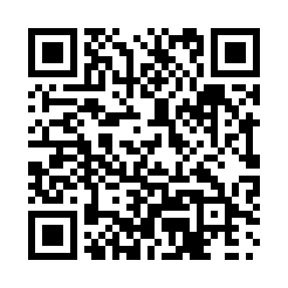

**Prayer times for Cap-aux-Os, Quebec, Canada**

**Wed 1 Jan 2025 - Fri 31 Jan 2025**

**High Latitude Method: Angle Based Rule**

**Prayer Calculation Method: Islamic Society of North America**

**Asar Calculation Method: Hanafi**

|  |  |  |  |  |  |  |  |
| --- | --- | --- | --- | --- | --- | --- | --- |
| **Date** | **Day** | **Fajr** | **Sunrise** | **Dhuhr** | **Asr** | **Maghrib** | **Isha** |
| 1 | Wed | 5:34 | 7:11 | 11:21 | 1:47 | 3:32 | 5:08 |
| 2 | Thu | 5:34 | 7:11 | 11:22 | 1:48 | 3:33 | 5:09 |
| 3 | Fri | 5:34 | 7:11 | 11:22 | 1:49 | 3:34 | 5:10 |
| 4 | Sat | 5:34 | 7:10 | 11:23 | 1:50 | 3:35 | 5:11 |
| 5 | Sun | 5:34 | 7:10 | 11:23 | 1:51 | 3:36 | 5:12 |
| 6 | Mon | 5:34 | 7:10 | 11:23 | 1:52 | 3:37 | 5:13 |
| 7 | Tue | 5:34 | 7:10 | 11:24 | 1:53 | 3:39 | 5:14 |
| 8 | Wed | 5:34 | 7:09 | 11:24 | 1:54 | 3:40 | 5:15 |
| 9 | Thu | 5:33 | 7:09 | 11:25 | 1:56 | 3:41 | 5:16 |
| 10 | Fri | 5:33 | 7:08 | 11:25 | 1:57 | 3:42 | 5:17 |
| 11 | Sat | 5:33 | 7:08 | 11:25 | 1:58 | 3:44 | 5:18 |
| 12 | Sun | 5:32 | 7:07 | 11:26 | 1:59 | 3:45 | 5:20 |
| 13 | Mon | 5:32 | 7:07 | 11:26 | 2:01 | 3:46 | 5:21 |
| 14 | Tue | 5:32 | 7:06 | 11:27 | 2:02 | 3:48 | 5:22 |
| 15 | Wed | 5:31 | 7:05 | 11:27 | 2:03 | 3:49 | 5:23 |
| 16 | Thu | 5:31 | 7:04 | 11:27 | 2:05 | 3:51 | 5:24 |
| 17 | Fri | 5:30 | 7:04 | 11:28 | 2:06 | 3:52 | 5:26 |
| 18 | Sat | 5:29 | 7:03 | 11:28 | 2:08 | 3:54 | 5:27 |
| 19 | Sun | 5:29 | 7:02 | 11:28 | 2:09 | 3:55 | 5:28 |
| 20 | Mon | 5:28 | 7:01 | 11:28 | 2:11 | 3:57 | 5:29 |
| 21 | Tue | 5:27 | 7:00 | 11:29 | 2:12 | 3:58 | 5:31 |
| 22 | Wed | 5:27 | 6:59 | 11:29 | 2:14 | 4:00 | 5:32 |
| 23 | Thu | 5:26 | 6:58 | 11:29 | 2:15 | 4:01 | 5:33 |
| 24 | Fri | 5:25 | 6:57 | 11:30 | 2:17 | 4:03 | 5:35 |
| 25 | Sat | 5:24 | 6:56 | 11:30 | 2:18 | 4:04 | 5:36 |
| 26 | Sun | 5:23 | 6:55 | 11:30 | 2:20 | 4:06 | 5:38 |
| 27 | Mon | 5:22 | 6:53 | 11:30 | 2:21 | 4:08 | 5:39 |
| 28 | Tue | 5:21 | 6:52 | 11:30 | 2:23 | 4:09 | 5:40 |
| 29 | Wed | 5:20 | 6:51 | 11:31 | 2:24 | 4:11 | 5:42 |
| 30 | Thu | 5:19 | 6:50 | 11:31 | 2:26 | 4:12 | 5:43 |
| 31 | Fri | 5:18 | 6:48 | 11:31 | 2:27 | 4:14 | 5:44 |

**Prayer times provided by https://www.salahtimes.com**