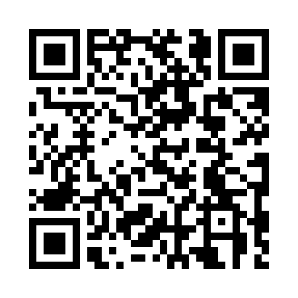
Prayer times for Marsh Lake, Yukon, Canada
Wed 1 May 2024 - Fri 31 May 2024
High Latitude Method: Angle Based Rule
Prayer Calculation Method: Islamic Society of North America
Asar Calculation Method: Hanafi

Date | Day | Fajr | Sunrise | Dhuhr | Asr | Maghrib | Isha
1 | Wed | 3:53 | 5:50 | 1:54 | 7:13 | 10:00 | 11:57
2 | Thu | 3:51 | 5:47 | 1:54 | 7:15 | 10:02 | 11:59
3 | Fri | 3:50 | 5:45 | 1:54 | 7:16 | 10:05 | 12:00
4 | Sat | 3:48 | 5:42 | 1:54 | 7:18 | 10:08 | 12:01
5 | Sun | 3:47 | 5:39 | 1:54 | 7:19 | 10:10 | 12:02
6 | Mon | 3:46 | 5:36 | 1:54 | 7:21 | 10:13 | 12:04
7 | Tue | 3:44 | 5:34 | 1:54 | 7:22 | 10:15 | 12:05
8 | Wed | 3:43 | 5:31 | 1:54 | 7:23 | 10:18 | 12:06
9 | Thu | 3:41 | 5:29 | 1:54 | 7:25 | 10:20 | 12:07
10 | Fri | 3:40 | 5:26 | 1:54 | 7:26 | 10:23 | 12:09
11 | Sat | 3:39 | 5:23 | 1:54 | 7:28 | 10:25 | 12:10
12 | Sun | 3:38 | 5:21 | 1:54 | 7:29 | 10:28 | 12:11
13 | Mon | 3:36 | 5:19 | 1:54 | 7:30 | 10:30 | 12:12
14 | Tue | 3:35 | 5:16 | 1:54 | 7:31 | 10:33 | 12:13
15 | Wed | 3:34 | 5:14 | 1:54 | 7:33 | 10:35 | 12:15
16 | Thu | 3:33 | 5:11 | 1:54 | 7:34 | 10:37 | 12:16
17 | Fri | 3:32 | 5:09 | 1:54 | 7:35 | 10:40 | 12:17
18 | Sat | 3:31 | 5:07 | 1:54 | 7:36 | 10:42 | 12:18
19 | Sun | 3:29 | 5:04 | 1:54 | 7:38 | 10:44 | 12:19
20 | Mon | 3:28 | 5:02 | 1:54 | 7:39 | 10:47 | 12:21
21 | Tue | 3:27 | 5:00 | 1:54 | 7:40 | 10:49 | 12:22
22 | Wed | 3:26 | 4:58 | 1:54 | 7:41 | 10:51 | 12:23
23 | Thu | 3:25 | 4:56 | 1:54 | 7:42 | 10:53 | 12:24
24 | Fri | 3:24 | 4:54 | 1:54 | 7:43 | 10:56 | 12:25
25 | Sat | 3:23 | 4:52 | 1:54 | 7:44 | 10:58 | 12:26
26 | Sun | 3:23 | 4:50 | 1:54 | 7:45 | 11:00 | 12:27
27 | Mon | 3:22 | 4:48 | 1:55 | 7:46 | 11:02 | 12:29
28 | Tue | 3:21 | 4:46 | 1:55 | 7:47 | 11:04 | 12:30
29 | Wed | 3:20 | 4:45 | 1:55 | 7:48 | 11:06 | 12:31
30 | Thu | 3:19 | 4:43 | 1:55 | 7:49 | 11:08 | 12:32
31 | Fri | 3:19 | 4:42 | 1:55 | 7:50 | 11:10 | 12:33
Prayer times provided by https://www.salahtimes.com

