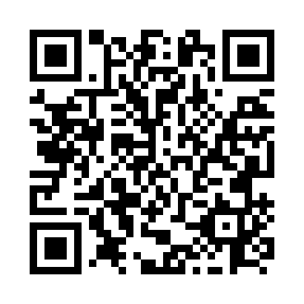
Prayer times for Glen Emma, Quebec, Canada
Wed 1 May 2024 - Fri 31 May 2024
High Latitude Method: Angle Based Rule
Prayer Calculation Method: Islamic Society of North America
Asar Calculation Method: Hanafi

Date | Day | Fajr | Sunrise | Dhuhr | Asr | Maghrib | Isha
1 | Wed | 3:26 | 5:09 | 12:26 | 5:29 | 7:43 | 9:27
2 | Thu | 3:23 | 5:08 | 12:25 | 5:30 | 7:44 | 9:29
3 | Fri | 3:21 | 5:06 | 12:25 | 5:31 | 7:46 | 9:31
4 | Sat | 3:19 | 5:04 | 12:25 | 5:32 | 7:47 | 9:33
5 | Sun | 3:17 | 5:03 | 12:25 | 5:33 | 7:48 | 9:35
6 | Mon | 3:14 | 5:01 | 12:25 | 5:34 | 7:50 | 9:37
7 | Tue | 3:12 | 5:00 | 12:25 | 5:34 | 7:51 | 9:39
8 | Wed | 3:10 | 4:58 | 12:25 | 5:35 | 7:53 | 9:42
9 | Thu | 3:08 | 4:57 | 12:25 | 5:36 | 7:54 | 9:44
10 | Fri | 3:05 | 4:55 | 12:25 | 5:37 | 7:55 | 9:46
11 | Sat | 3:03 | 4:54 | 12:25 | 5:38 | 7:57 | 9:48
12 | Sun | 3:01 | 4:53 | 12:25 | 5:38 | 7:58 | 9:50
13 | Mon | 2:59 | 4:51 | 12:25 | 5:39 | 7:59 | 9:52
14 | Tue | 2:57 | 4:50 | 12:25 | 5:40 | 8:01 | 9:54
15 | Wed | 2:54 | 4:49 | 12:25 | 5:41 | 8:02 | 9:57
16 | Thu | 2:52 | 4:47 | 12:25 | 5:42 | 8:03 | 9:59
17 | Fri | 2:50 | 4:46 | 12:25 | 5:42 | 8:04 | 10:01
18 | Sat | 2:48 | 4:45 | 12:25 | 5:43 | 8:06 | 10:03
19 | Sun | 2:46 | 4:44 | 12:25 | 5:44 | 8:07 | 10:05
20 | Mon | 2:44 | 4:43 | 12:25 | 5:44 | 8:08 | 10:07
21 | Tue | 2:42 | 4:42 | 12:25 | 5:45 | 8:09 | 10:09
22 | Wed | 2:40 | 4:41 | 12:25 | 5:46 | 8:10 | 10:11
23 | Thu | 2:38 | 4:40 | 12:25 | 5:47 | 8:12 | 10:13
24 | Fri | 2:37 | 4:39 | 12:25 | 5:47 | 8:13 | 10:15
25 | Sat | 2:35 | 4:38 | 12:26 | 5:48 | 8:14 | 10:17
26 | Sun | 2:33 | 4:37 | 12:26 | 5:49 | 8:15 | 10:19
27 | Mon | 2:31 | 4:36 | 12:26 | 5:49 | 8:16 | 10:21
28 | Tue | 2:31 | 4:35 | 12:26 | 5:50 | 8:17 | 10:22
29 | Wed | 2:30 | 4:34 | 12:26 | 5:51 | 8:18 | 10:22
30 | Thu | 2:30 | 4:34 | 12:26 | 5:51 | 8:19 | 10:23
31 | Fri | 2:30 | 4:33 | 12:26 | 5:52 | 8:20 | 10:23
Prayer times provided by https://www.salahtimes.com

