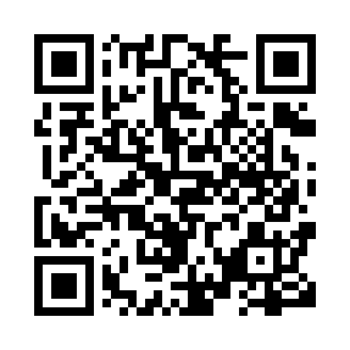

**Prayer times for Fort Hall, Manitoba, Canada**

**Sun 1 Sep 2024 - Mon 30 Sep 2024**

**High Latitude Method: Angle Based Rule**

**Prayer Calculation Method: Islamic Society of North America**

**Asar Calculation Method: Hanafi**

|  |  |  |  |  |  |  |  |
| --- | --- | --- | --- | --- | --- | --- | --- |
| **Date** | **Day** | **Fajr** | **Sunrise** | **Dhuhr** | **Asr** | **Maghrib** | **Isha** |
| 1 | Sun | 4:30 | 6:43 | 1:45 | 6:24 | 8:45 | 10:57 |
| 2 | Mon | 4:34 | 6:46 | 1:45 | 6:21 | 8:42 | 10:53 |
| 3 | Tue | 4:38 | 6:48 | 1:44 | 6:19 | 8:39 | 10:49 |
| 4 | Wed | 4:41 | 6:50 | 1:44 | 6:17 | 8:36 | 10:45 |
| 5 | Thu | 4:44 | 6:53 | 1:44 | 6:15 | 8:34 | 10:41 |
| 6 | Fri | 4:48 | 6:55 | 1:43 | 6:12 | 8:31 | 10:37 |
| 7 | Sat | 4:51 | 6:57 | 1:43 | 6:10 | 8:28 | 10:33 |
| 8 | Sun | 4:54 | 6:59 | 1:43 | 6:08 | 8:25 | 10:29 |
| 9 | Mon | 4:58 | 7:02 | 1:42 | 6:05 | 8:22 | 10:25 |
| 10 | Tue | 5:01 | 7:04 | 1:42 | 6:03 | 8:19 | 10:21 |
| 11 | Wed | 5:04 | 7:06 | 1:42 | 6:00 | 8:16 | 10:18 |
| 12 | Thu | 5:07 | 7:09 | 1:41 | 5:58 | 8:13 | 10:14 |
| 13 | Fri | 5:10 | 7:11 | 1:41 | 5:56 | 8:10 | 10:10 |
| 14 | Sat | 5:13 | 7:13 | 1:41 | 5:53 | 8:07 | 10:06 |
| 15 | Sun | 5:16 | 7:15 | 1:40 | 5:51 | 8:04 | 10:03 |
| 16 | Mon | 5:19 | 7:18 | 1:40 | 5:48 | 8:01 | 9:59 |
| 17 | Tue | 5:22 | 7:20 | 1:39 | 5:46 | 7:58 | 9:56 |
| 18 | Wed | 5:24 | 7:22 | 1:39 | 5:43 | 7:55 | 9:52 |
| 19 | Thu | 5:27 | 7:24 | 1:39 | 5:41 | 7:52 | 9:49 |
| 20 | Fri | 5:30 | 7:27 | 1:38 | 5:38 | 7:49 | 9:45 |
| 21 | Sat | 5:33 | 7:29 | 1:38 | 5:36 | 7:46 | 9:42 |
| 22 | Sun | 5:35 | 7:31 | 1:38 | 5:33 | 7:43 | 9:38 |
| 23 | Mon | 5:38 | 7:34 | 1:37 | 5:31 | 7:40 | 9:35 |
| 24 | Tue | 5:41 | 7:36 | 1:37 | 5:28 | 7:37 | 9:32 |
| 25 | Wed | 5:43 | 7:38 | 1:37 | 5:26 | 7:34 | 9:28 |
| 26 | Thu | 5:46 | 7:40 | 1:36 | 5:23 | 7:31 | 9:25 |
| 27 | Fri | 5:49 | 7:43 | 1:36 | 5:21 | 7:28 | 9:22 |
| 28 | Sat | 5:51 | 7:45 | 1:36 | 5:18 | 7:25 | 9:18 |
| 29 | Sun | 5:54 | 7:47 | 1:35 | 5:16 | 7:22 | 9:15 |
| 30 | Mon | 5:56 | 7:50 | 1:35 | 5:13 | 7:19 | 9:12 |

**Prayer times provided by https://www.salahtimes.com**