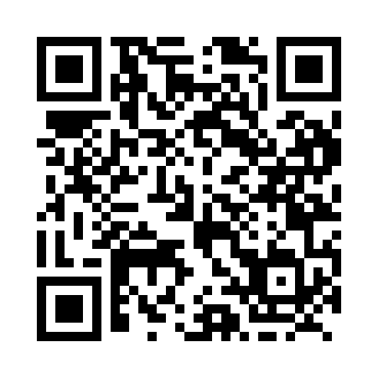
Prayer times for The Light, Quebec, Canada
Wed 1 May 2024 - Fri 31 May 2024
High Latitude Method: Angle Based Rule
Prayer Calculation Method: Islamic Society of North America
Asar Calculation Method: Hanafi

Date | Day | Fajr | Sunrise | Dhuhr | Asr | Maghrib | Isha
1 | Wed | 2:24 | 4:20 | 11:46 | 4:53 | 7:13 | 9:09
2 | Thu | 2:21 | 4:18 | 11:46 | 4:54 | 7:14 | 9:12
3 | Fri | 2:18 | 4:16 | 11:46 | 4:55 | 7:16 | 9:15
4 | Sat | 2:15 | 4:14 | 11:46 | 4:56 | 7:17 | 9:17
5 | Sun | 2:12 | 4:13 | 11:45 | 4:57 | 7:19 | 9:20
6 | Mon | 2:09 | 4:11 | 11:45 | 4:58 | 7:21 | 9:23
7 | Tue | 2:07 | 4:09 | 11:45 | 4:59 | 7:22 | 9:26
8 | Wed | 2:04 | 4:08 | 11:45 | 5:00 | 7:24 | 9:28
9 | Thu | 2:01 | 4:06 | 11:45 | 5:01 | 7:25 | 9:31
10 | Fri | 1:58 | 4:04 | 11:45 | 5:02 | 7:27 | 9:34
11 | Sat | 1:55 | 4:03 | 11:45 | 5:03 | 7:28 | 9:37
12 | Sun | 1:53 | 4:01 | 11:45 | 5:04 | 7:30 | 9:38
13 | Mon | 1:53 | 4:00 | 11:45 | 5:04 | 7:31 | 9:38
14 | Tue | 1:52 | 3:58 | 11:45 | 5:05 | 7:33 | 9:39
15 | Wed | 1:51 | 3:57 | 11:45 | 5:06 | 7:34 | 9:40
16 | Thu | 1:50 | 3:55 | 11:45 | 5:07 | 7:36 | 9:41
17 | Fri | 1:50 | 3:54 | 11:45 | 5:08 | 7:37 | 9:41
18 | Sat | 1:49 | 3:52 | 11:45 | 5:09 | 7:39 | 9:42
19 | Sun | 1:48 | 3:51 | 11:45 | 5:10 | 7:40 | 9:43
20 | Mon | 1:48 | 3:50 | 11:45 | 5:10 | 7:42 | 9:44
21 | Tue | 1:47 | 3:48 | 11:45 | 5:11 | 7:43 | 9:44
22 | Wed | 1:47 | 3:47 | 11:46 | 5:12 | 7:44 | 9:45
23 | Thu | 1:46 | 3:46 | 11:46 | 5:13 | 7:46 | 9:46
24 | Fri | 1:45 | 3:45 | 11:46 | 5:14 | 7:47 | 9:46
25 | Sat | 1:45 | 3:44 | 11:46 | 5:14 | 7:48 | 9:47
26 | Sun | 1:45 | 3:43 | 11:46 | 5:15 | 7:50 | 9:48
27 | Mon | 1:44 | 3:42 | 11:46 | 5:16 | 7:51 | 9:49
28 | Tue | 1:44 | 3:41 | 11:46 | 5:17 | 7:52 | 9:49
29 | Wed | 1:43 | 3:40 | 11:46 | 5:17 | 7:53 | 9:50
30 | Thu | 1:43 | 3:39 | 11:46 | 5:18 | 7:54 | 9:50
31 | Fri | 1:43 | 3:38 | 11:47 | 5:19 | 7:55 | 9:51
Prayer times provided by https://www.salahtimes.com

