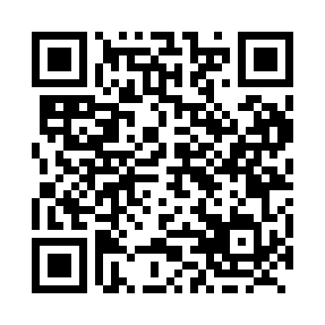
Prayer times for Wekweeti, Northwest Territories, Canada
Wed 1 May 2024 - Fri 31 May 2024
High Latitude Method: Angle Based Rule
Prayer Calculation Method: Islamic Society of North America
Asar Calculation Method: Hanafi

Date | Day | Fajr | Sunrise | Dhuhr | Asr | Maghrib | Isha
1 | Wed | 3:20 | 5:06 | 1:34 | 6:59 | 10:03 | 11:49
2 | Thu | 3:18 | 5:02 | 1:34 | 7:00 | 10:07 | 11:51
3 | Fri | 3:17 | 4:59 | 1:34 | 7:02 | 10:10 | 11:52
4 | Sat | 3:15 | 4:56 | 1:33 | 7:04 | 10:13 | 11:54
5 | Sun | 3:13 | 4:52 | 1:33 | 7:06 | 10:16 | 11:55
6 | Mon | 3:11 | 4:49 | 1:33 | 7:07 | 10:20 | 11:57
7 | Tue | 3:10 | 4:45 | 1:33 | 7:09 | 10:23 | 11:58
8 | Wed | 3:08 | 4:42 | 1:33 | 7:11 | 10:26 | 12:00
9 | Thu | 3:06 | 4:39 | 1:33 | 7:12 | 10:29 | 12:02
10 | Fri | 3:05 | 4:35 | 1:33 | 7:14 | 10:33 | 12:03
11 | Sat | 3:03 | 4:32 | 1:33 | 7:15 | 10:36 | 12:05
12 | Sun | 3:01 | 4:29 | 1:33 | 7:17 | 10:39 | 12:07
13 | Mon | 3:00 | 4:25 | 1:33 | 7:18 | 10:43 | 12:08
14 | Tue | 2:58 | 4:22 | 1:33 | 7:20 | 10:46 | 12:10
15 | Wed | 2:56 | 4:19 | 1:33 | 7:21 | 10:49 | 12:12
16 | Thu | 2:55 | 4:16 | 1:33 | 7:23 | 10:52 | 12:13
17 | Fri | 2:53 | 4:12 | 1:33 | 7:24 | 10:56 | 12:15
18 | Sat | 2:52 | 4:09 | 1:33 | 7:26 | 10:59 | 12:16
19 | Sun | 2:50 | 4:06 | 1:33 | 7:27 | 11:02 | 12:18
20 | Mon | 2:49 | 4:03 | 1:33 | 7:29 | 11:05 | 12:20
21 | Tue | 2:47 | 4:00 | 1:33 | 7:30 | 11:09 | 12:21
22 | Wed | 2:46 | 3:57 | 1:33 | 7:31 | 11:12 | 12:23
23 | Thu | 2:44 | 3:54 | 1:34 | 7:33 | 11:15 | 12:25
24 | Fri | 2:43 | 3:51 | 1:34 | 7:34 | 11:18 | 12:26
25 | Sat | 2:41 | 3:48 | 1:34 | 7:35 | 11:21 | 12:28
26 | Sun | 2:40 | 3:45 | 1:34 | 7:36 | 11:24 | 12:29
27 | Mon | 2:38 | 3:42 | 1:34 | 7:37 | 11:27 | 12:31
28 | Tue | 2:37 | 3:39 | 1:34 | 7:39 | 11:30 | 12:33
29 | Wed | 2:36 | 3:37 | 1:34 | 7:40 | 11:33 | 12:34
30 | Thu | 2:35 | 3:34 | 1:34 | 7:41 | 11:36 | 12:36
31 | Fri | 2:33 | 3:31 | 1:35 | 7:42 | 11:39 | 12:37
Prayer times provided by https://www.salahtimes.com

