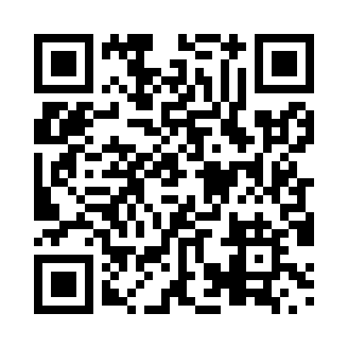
Prayer times for Bout-de-l'Ile, Quebec, Canada
Mon 1 Apr 2024 - Tue 30 Apr 2024
High Latitude Method: Angle Based Rule
Prayer Calculation Method: Islamic Society of North America
Asar Calculation Method: Hanafi

Date | Day | Fajr | Sunrise | Dhuhr | Asr | Maghrib | Isha
1 | Mon | 5:09 | 6:33 | 12:58 | 5:27 | 7:23 | 8:48
2 | Tue | 5:06 | 6:31 | 12:57 | 5:28 | 7:24 | 8:49
3 | Wed | 5:04 | 6:29 | 12:57 | 5:29 | 7:26 | 8:51
4 | Thu | 5:02 | 6:27 | 12:57 | 5:30 | 7:27 | 8:52
5 | Fri | 5:00 | 6:25 | 12:56 | 5:31 | 7:28 | 8:54
6 | Sat | 4:58 | 6:24 | 12:56 | 5:31 | 7:29 | 8:55
7 | Sun | 4:56 | 6:22 | 12:56 | 5:32 | 7:31 | 8:57
8 | Mon | 4:54 | 6:20 | 12:56 | 5:33 | 7:32 | 8:59
9 | Tue | 4:51 | 6:18 | 12:55 | 5:34 | 7:33 | 9:00
10 | Wed | 4:49 | 6:16 | 12:55 | 5:35 | 7:35 | 9:02
11 | Thu | 4:47 | 6:14 | 12:55 | 5:36 | 7:36 | 9:04
12 | Fri | 4:45 | 6:13 | 12:55 | 5:37 | 7:37 | 9:05
13 | Sat | 4:43 | 6:11 | 12:54 | 5:38 | 7:39 | 9:07
14 | Sun | 4:41 | 6:09 | 12:54 | 5:38 | 7:40 | 9:09
15 | Mon | 4:38 | 6:07 | 12:54 | 5:39 | 7:41 | 9:10
16 | Tue | 4:36 | 6:05 | 12:54 | 5:40 | 7:43 | 9:12
17 | Wed | 4:34 | 6:04 | 12:53 | 5:41 | 7:44 | 9:14
18 | Thu | 4:32 | 6:02 | 12:53 | 5:42 | 7:45 | 9:15
19 | Fri | 4:30 | 6:00 | 12:53 | 5:43 | 7:46 | 9:17
20 | Sat | 4:28 | 5:58 | 12:53 | 5:43 | 7:48 | 9:19
21 | Sun | 4:25 | 5:57 | 12:52 | 5:44 | 7:49 | 9:21
22 | Mon | 4:23 | 5:55 | 12:52 | 5:45 | 7:50 | 9:22
23 | Tue | 4:21 | 5:53 | 12:52 | 5:46 | 7:52 | 9:24
24 | Wed | 4:19 | 5:52 | 12:52 | 5:47 | 7:53 | 9:26
25 | Thu | 4:17 | 5:50 | 12:52 | 5:47 | 7:54 | 9:28
26 | Fri | 4:15 | 5:48 | 12:52 | 5:48 | 7:55 | 9:29
27 | Sat | 4:13 | 5:47 | 12:51 | 5:49 | 7:57 | 9:31
28 | Sun | 4:11 | 5:45 | 12:51 | 5:50 | 7:58 | 9:33
29 | Mon | 4:09 | 5:44 | 12:51 | 5:51 | 7:59 | 9:35
30 | Tue | 4:07 | 5:42 | 12:51 | 5:51 | 8:01 | 9:37
Prayer times provided by https://www.salahtimes.com

