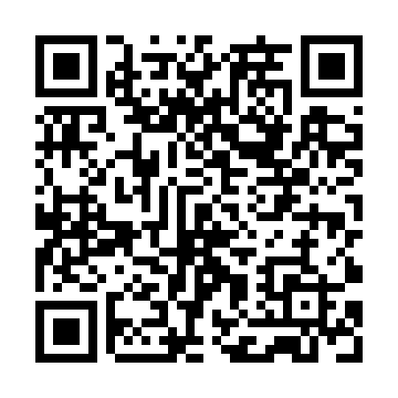
Prayer times for Baltmiskiai, Lithuania
Wed 1 May 2024 - Fri 31 May 2024
High Latitude Method: Angle Based Rule
Prayer Calculation Method: Muslim World League
Asar Calculation Method: Hanafi

Date | Day | Fajr | Sunrise | Dhuhr | Asr | Maghrib | Isha
1 | Wed | 3:14 | 5:49 | 1:31 | 6:43 | 9:13 | 11:39
2 | Thu | 3:13 | 5:47 | 1:30 | 6:44 | 9:15 | 11:40
3 | Fri | 3:12 | 5:45 | 1:30 | 6:45 | 9:17 | 11:41
4 | Sat | 3:11 | 5:42 | 1:30 | 6:47 | 9:19 | 11:42
5 | Sun | 3:11 | 5:40 | 1:30 | 6:48 | 9:21 | 11:43
6 | Mon | 3:10 | 5:38 | 1:30 | 6:49 | 9:23 | 11:43
7 | Tue | 3:09 | 5:36 | 1:30 | 6:50 | 9:25 | 11:44
8 | Wed | 3:08 | 5:34 | 1:30 | 6:51 | 9:27 | 11:45
9 | Thu | 3:07 | 5:32 | 1:30 | 6:52 | 9:29 | 11:46
10 | Fri | 3:06 | 5:30 | 1:30 | 6:53 | 9:31 | 11:47
11 | Sat | 3:05 | 5:28 | 1:30 | 6:55 | 9:33 | 11:47
12 | Sun | 3:05 | 5:26 | 1:30 | 6:56 | 9:35 | 11:48
13 | Mon | 3:04 | 5:24 | 1:30 | 6:57 | 9:37 | 11:49
14 | Tue | 3:03 | 5:22 | 1:30 | 6:58 | 9:39 | 11:50
15 | Wed | 3:02 | 5:20 | 1:30 | 6:59 | 9:40 | 11:51
16 | Thu | 3:02 | 5:19 | 1:30 | 7:00 | 9:42 | 11:52
17 | Fri | 3:01 | 5:17 | 1:30 | 7:01 | 9:44 | 11:52
18 | Sat | 3:00 | 5:15 | 1:30 | 7:02 | 9:46 | 11:53
19 | Sun | 3:00 | 5:13 | 1:30 | 7:03 | 9:48 | 11:54
20 | Mon | 2:59 | 5:12 | 1:30 | 7:04 | 9:49 | 11:55
21 | Tue | 2:58 | 5:10 | 1:30 | 7:05 | 9:51 | 11:55
22 | Wed | 2:58 | 5:09 | 1:30 | 7:06 | 9:53 | 11:56
23 | Thu | 2:57 | 5:07 | 1:30 | 7:07 | 9:54 | 11:57
24 | Fri | 2:57 | 5:06 | 1:30 | 7:08 | 9:56 | 11:58
25 | Sat | 2:56 | 5:04 | 1:31 | 7:09 | 9:58 | 11:59
26 | Sun | 2:56 | 5:03 | 1:31 | 7:10 | 9:59 | 11:59
27 | Mon | 2:55 | 5:01 | 1:31 | 7:10 | 10:01 | 12:00
28 | Tue | 2:55 | 5:00 | 1:31 | 7:11 | 10:02 | 12:01
29 | Wed | 2:54 | 4:59 | 1:31 | 7:12 | 10:04 | 12:01
30 | Thu | 2:54 | 4:58 | 1:31 | 7:13 | 10:05 | 12:02
31 | Fri | 2:54 | 4:57 | 1:31 | 7:14 | 10:07 | 12:03
Prayer times provided by https://www.salahtimes.com

