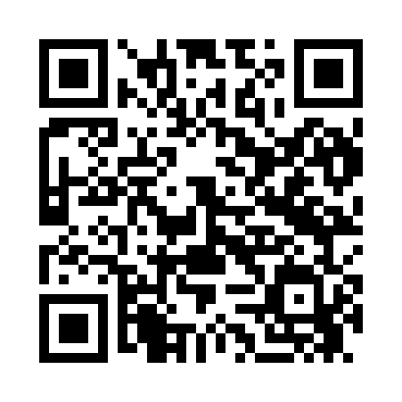

**Prayer times for Abissaare, Estonia**

**Sun 1 Sep 2024 - Mon 30 Sep 2024**

**High Latitude Method: Angle Based Rule**

**Prayer Calculation Method: Muslim World League**

**Asar Calculation Method: Hanafi**

|  |  |  |  |  |  |  |  |
| --- | --- | --- | --- | --- | --- | --- | --- |
| **Date** | **Day** | **Fajr** | **Sunrise** | **Dhuhr** | **Asr** | **Maghrib** | **Isha** |
| 1 | Sun | 3:33 | 6:14 | 1:13 | 5:52 | 8:11 | 10:39 |
| 2 | Mon | 3:37 | 6:16 | 1:13 | 5:50 | 8:08 | 10:34 |
| 3 | Tue | 3:41 | 6:18 | 1:12 | 5:48 | 8:06 | 10:30 |
| 4 | Wed | 3:44 | 6:20 | 1:12 | 5:46 | 8:03 | 10:26 |
| 5 | Thu | 3:48 | 6:22 | 1:12 | 5:44 | 8:00 | 10:22 |
| 6 | Fri | 3:52 | 6:24 | 1:11 | 5:41 | 7:57 | 10:18 |
| 7 | Sat | 3:55 | 6:26 | 1:11 | 5:39 | 7:54 | 10:14 |
| 8 | Sun | 3:59 | 6:29 | 1:11 | 5:37 | 7:51 | 10:10 |
| 9 | Mon | 4:02 | 6:31 | 1:10 | 5:35 | 7:49 | 10:06 |
| 10 | Tue | 4:06 | 6:33 | 1:10 | 5:32 | 7:46 | 10:02 |
| 11 | Wed | 4:09 | 6:35 | 1:10 | 5:30 | 7:43 | 9:59 |
| 12 | Thu | 4:12 | 6:37 | 1:09 | 5:28 | 7:40 | 9:55 |
| 13 | Fri | 4:15 | 6:39 | 1:09 | 5:26 | 7:37 | 9:51 |
| 14 | Sat | 4:18 | 6:41 | 1:09 | 5:23 | 7:34 | 9:47 |
| 15 | Sun | 4:21 | 6:44 | 1:08 | 5:21 | 7:32 | 9:44 |
| 16 | Mon | 4:24 | 6:46 | 1:08 | 5:19 | 7:29 | 9:40 |
| 17 | Tue | 4:27 | 6:48 | 1:07 | 5:16 | 7:26 | 9:37 |
| 18 | Wed | 4:30 | 6:50 | 1:07 | 5:14 | 7:23 | 9:33 |
| 19 | Thu | 4:33 | 6:52 | 1:07 | 5:12 | 7:20 | 9:30 |
| 20 | Fri | 4:36 | 6:54 | 1:06 | 5:09 | 7:17 | 9:26 |
| 21 | Sat | 4:39 | 6:56 | 1:06 | 5:07 | 7:14 | 9:23 |
| 22 | Sun | 4:41 | 6:59 | 1:06 | 5:04 | 7:12 | 9:19 |
| 23 | Mon | 4:44 | 7:01 | 1:05 | 5:02 | 7:09 | 9:16 |
| 24 | Tue | 4:47 | 7:03 | 1:05 | 4:59 | 7:06 | 9:13 |
| 25 | Wed | 4:50 | 7:05 | 1:05 | 4:57 | 7:03 | 9:10 |
| 26 | Thu | 4:52 | 7:07 | 1:04 | 4:55 | 7:00 | 9:06 |
| 27 | Fri | 4:55 | 7:09 | 1:04 | 4:52 | 6:57 | 9:03 |
| 28 | Sat | 4:57 | 7:12 | 1:04 | 4:50 | 6:54 | 9:00 |
| 29 | Sun | 5:00 | 7:14 | 1:03 | 4:47 | 6:52 | 8:57 |
| 30 | Mon | 5:02 | 7:16 | 1:03 | 4:45 | 6:49 | 8:54 |

**Prayer times provided by https://www.salahtimes.com**