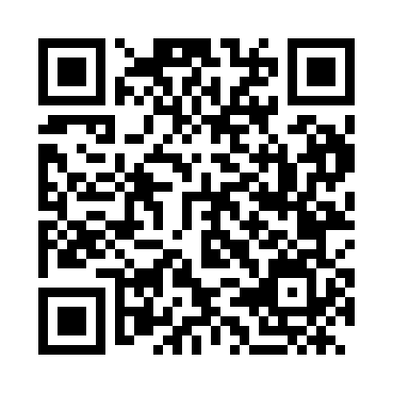
Prayer times for Koromacno, Croatia
Wed 1 May 2024 - Fri 31 May 2024
High Latitude Method: None
Prayer Calculation Method: Muslim World League
Asar Calculation Method: Shafi

Date | Day | Fajr | Sunrise | Dhuhr | Asr | Maghrib | Isha
1 | Wed | 3:55 | 5:52 | 1:01 | 4:57 | 8:09 | 9:59
2 | Thu | 3:53 | 5:51 | 1:00 | 4:57 | 8:11 | 10:01
3 | Fri | 3:51 | 5:50 | 1:00 | 4:58 | 8:12 | 10:03
4 | Sat | 3:49 | 5:48 | 1:00 | 4:58 | 8:13 | 10:05
5 | Sun | 3:46 | 5:47 | 1:00 | 4:59 | 8:14 | 10:07
6 | Mon | 3:44 | 5:45 | 1:00 | 4:59 | 8:16 | 10:09
7 | Tue | 3:42 | 5:44 | 1:00 | 4:59 | 8:17 | 10:11
8 | Wed | 3:40 | 5:43 | 1:00 | 5:00 | 8:18 | 10:13
9 | Thu | 3:38 | 5:41 | 1:00 | 5:00 | 8:19 | 10:14
10 | Fri | 3:36 | 5:40 | 1:00 | 5:01 | 8:20 | 10:16
11 | Sat | 3:34 | 5:39 | 1:00 | 5:01 | 8:21 | 10:18
12 | Sun | 3:32 | 5:38 | 1:00 | 5:01 | 8:23 | 10:20
13 | Mon | 3:30 | 5:37 | 1:00 | 5:02 | 8:24 | 10:22
14 | Tue | 3:28 | 5:35 | 1:00 | 5:02 | 8:25 | 10:24
15 | Wed | 3:26 | 5:34 | 1:00 | 5:03 | 8:26 | 10:26
16 | Thu | 3:24 | 5:33 | 1:00 | 5:03 | 8:27 | 10:28
17 | Fri | 3:22 | 5:32 | 1:00 | 5:03 | 8:28 | 10:30
18 | Sat | 3:20 | 5:31 | 1:00 | 5:04 | 8:29 | 10:32
19 | Sun | 3:18 | 5:30 | 1:00 | 5:04 | 8:31 | 10:34
20 | Mon | 3:16 | 5:29 | 1:00 | 5:04 | 8:32 | 10:35
21 | Tue | 3:14 | 5:28 | 1:00 | 5:05 | 8:33 | 10:37
22 | Wed | 3:12 | 5:27 | 1:00 | 5:05 | 8:34 | 10:39
23 | Thu | 3:10 | 5:26 | 1:00 | 5:06 | 8:35 | 10:41
24 | Fri | 3:09 | 5:26 | 1:00 | 5:06 | 8:36 | 10:43
25 | Sat | 3:07 | 5:25 | 1:01 | 5:06 | 8:37 | 10:44
26 | Sun | 3:05 | 5:24 | 1:01 | 5:07 | 8:38 | 10:46
27 | Mon | 3:04 | 5:23 | 1:01 | 5:07 | 8:39 | 10:48
28 | Tue | 3:02 | 5:23 | 1:01 | 5:07 | 8:40 | 10:49
29 | Wed | 3:01 | 5:22 | 1:01 | 5:08 | 8:41 | 10:51
30 | Thu | 2:59 | 5:21 | 1:01 | 5:08 | 8:41 | 10:53
31 | Fri | 2:58 | 5:21 | 1:01 | 5:09 | 8:42 | 10:54
Prayer times provided by https://www.salahtimes.com

