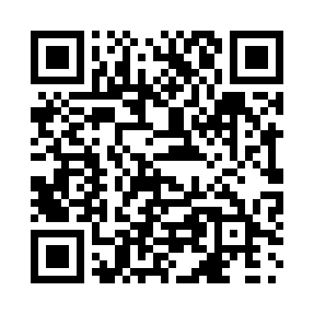
Prayer times for Salt River, Northwest Territories, Canada
Wed 1 May 2024 - Fri 31 May 2024
High Latitude Method: Angle Based Rule
Prayer Calculation Method: Islamic Society of North America
Asar Calculation Method: Hanafi

Date | Day | Fajr | Sunrise | Dhuhr | Asr | Maghrib | Isha
1 | Wed | 3:25 | 5:24 | 1:26 | 6:44 | 9:29 | 11:28
2 | Thu | 3:24 | 5:21 | 1:26 | 6:46 | 9:32 | 11:29
3 | Fri | 3:23 | 5:19 | 1:26 | 6:47 | 9:34 | 11:30
4 | Sat | 3:21 | 5:16 | 1:26 | 6:49 | 9:37 | 11:31
5 | Sun | 3:20 | 5:13 | 1:26 | 6:50 | 9:39 | 11:33
6 | Mon | 3:18 | 5:11 | 1:26 | 6:51 | 9:42 | 11:34
7 | Tue | 3:17 | 5:08 | 1:25 | 6:53 | 9:44 | 11:35
8 | Wed | 3:16 | 5:06 | 1:25 | 6:54 | 9:46 | 11:36
9 | Thu | 3:15 | 5:03 | 1:25 | 6:56 | 9:49 | 11:37
10 | Fri | 3:13 | 5:01 | 1:25 | 6:57 | 9:51 | 11:39
11 | Sat | 3:12 | 4:58 | 1:25 | 6:58 | 9:54 | 11:40
12 | Sun | 3:11 | 4:56 | 1:25 | 7:00 | 9:56 | 11:41
13 | Mon | 3:10 | 4:53 | 1:25 | 7:01 | 9:59 | 11:42
14 | Tue | 3:08 | 4:51 | 1:25 | 7:02 | 10:01 | 11:43
15 | Wed | 3:07 | 4:49 | 1:25 | 7:03 | 10:03 | 11:45
16 | Thu | 3:06 | 4:46 | 1:25 | 7:05 | 10:06 | 11:46
17 | Fri | 3:05 | 4:44 | 1:25 | 7:06 | 10:08 | 11:47
18 | Sat | 3:04 | 4:42 | 1:25 | 7:07 | 10:10 | 11:48
19 | Sun | 3:03 | 4:40 | 1:25 | 7:08 | 10:13 | 11:49
20 | Mon | 3:02 | 4:37 | 1:26 | 7:09 | 10:15 | 11:50
21 | Tue | 3:01 | 4:35 | 1:26 | 7:10 | 10:17 | 11:52
22 | Wed | 3:00 | 4:33 | 1:26 | 7:12 | 10:19 | 11:53
23 | Thu | 2:59 | 4:31 | 1:26 | 7:13 | 10:21 | 11:54
24 | Fri | 2:58 | 4:29 | 1:26 | 7:14 | 10:23 | 11:55
25 | Sat | 2:57 | 4:27 | 1:26 | 7:15 | 10:25 | 11:56
26 | Sun | 2:56 | 4:26 | 1:26 | 7:16 | 10:28 | 11:57
27 | Mon | 2:55 | 4:24 | 1:26 | 7:17 | 10:30 | 11:58
28 | Tue | 2:54 | 4:22 | 1:26 | 7:18 | 10:31 | 11:59
29 | Wed | 2:54 | 4:20 | 1:26 | 7:19 | 10:33 | 12:00
30 | Thu | 2:53 | 4:19 | 1:27 | 7:20 | 10:35 | 12:01
31 | Fri | 2:52 | 4:17 | 1:27 | 7:21 | 10:37 | 12:02
Prayer times provided by https://www.salahtimes.com

