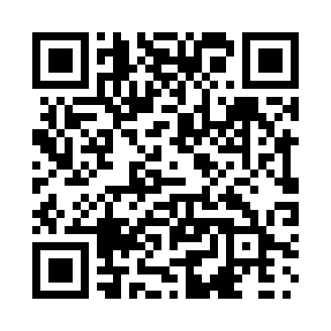
Prayer times for Brisay, Quebec, Canada
Mon 1 Jul 2024 - Wed 31 Jul 2024
High Latitude Method: Angle Based Rule
Prayer Calculation Method: Islamic Society of North America
Asar Calculation Method: Hanafi

Date | Day | Fajr | Sunrise | Dhuhr | Asr | Maghrib | Isha
1 | Mon | 2:29 | 4:12 | 12:46 | 6:29 | 9:20 | 11:03
2 | Tue | 2:29 | 4:13 | 12:46 | 6:29 | 9:19 | 11:03
3 | Wed | 2:30 | 4:14 | 12:46 | 6:29 | 9:19 | 11:03
4 | Thu | 2:31 | 4:15 | 12:47 | 6:29 | 9:18 | 11:02
5 | Fri | 2:31 | 4:16 | 12:47 | 6:28 | 9:18 | 11:02
6 | Sat | 2:32 | 4:17 | 12:47 | 6:28 | 9:17 | 11:02
7 | Sun | 2:32 | 4:18 | 12:47 | 6:28 | 9:16 | 11:01
8 | Mon | 2:33 | 4:19 | 12:47 | 6:27 | 9:15 | 11:01
9 | Tue | 2:34 | 4:20 | 12:47 | 6:27 | 9:14 | 11:01
10 | Wed | 2:34 | 4:21 | 12:48 | 6:27 | 9:13 | 11:00
11 | Thu | 2:35 | 4:22 | 12:48 | 6:26 | 9:12 | 11:00
12 | Fri | 2:36 | 4:24 | 12:48 | 6:26 | 9:11 | 10:59
13 | Sat | 2:36 | 4:25 | 12:48 | 6:25 | 9:10 | 10:59
14 | Sun | 2:37 | 4:26 | 12:48 | 6:25 | 9:09 | 10:58
15 | Mon | 2:38 | 4:28 | 12:48 | 6:24 | 9:08 | 10:58
16 | Tue | 2:38 | 4:29 | 12:48 | 6:24 | 9:07 | 10:57
17 | Wed | 2:39 | 4:30 | 12:48 | 6:23 | 9:05 | 10:57
18 | Thu | 2:40 | 4:32 | 12:48 | 6:22 | 9:04 | 10:56
19 | Fri | 2:41 | 4:33 | 12:48 | 6:21 | 9:03 | 10:55
20 | Sat | 2:42 | 4:35 | 12:48 | 6:21 | 9:01 | 10:55
21 | Sun | 2:42 | 4:36 | 12:49 | 6:20 | 9:00 | 10:54
22 | Mon | 2:43 | 4:38 | 12:49 | 6:19 | 8:58 | 10:53
23 | Tue | 2:44 | 4:40 | 12:49 | 6:18 | 8:57 | 10:52
24 | Wed | 2:45 | 4:41 | 12:49 | 6:17 | 8:55 | 10:52
25 | Thu | 2:46 | 4:43 | 12:49 | 6:16 | 8:54 | 10:51
26 | Fri | 2:46 | 4:44 | 12:49 | 6:16 | 8:52 | 10:50
27 | Sat | 2:47 | 4:46 | 12:49 | 6:15 | 8:50 | 10:49
28 | Sun | 2:48 | 4:48 | 12:49 | 6:14 | 8:48 | 10:48
29 | Mon | 2:49 | 4:49 | 12:49 | 6:12 | 8:47 | 10:47
30 | Tue | 2:50 | 4:51 | 12:48 | 6:11 | 8:45 | 10:46
31 | Wed | 2:50 | 4:53 | 12:48 | 6:10 | 8:43 | 10:46
Prayer times provided by https://www.salahtimes.com

