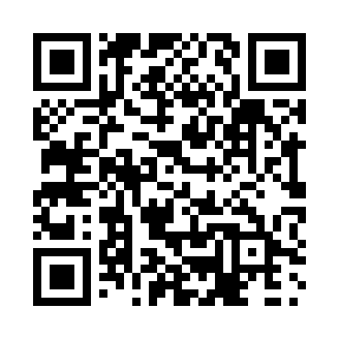

**Prayer times for Penney's Room, Quebec, Canada**

**Sun 1 Sep 2024 - Mon 30 Sep 2024**

**High Latitude Method: Angle Based Rule**

**Prayer Calculation Method: Islamic Society of North America**

**Asar Calculation Method: Hanafi**

|  |  |  |  |  |  |  |  |
| --- | --- | --- | --- | --- | --- | --- | --- |
| **Date** | **Day** | **Fajr** | **Sunrise** | **Dhuhr** | **Asr** | **Maghrib** | **Isha** |
| 1 | Sun | 3:22 | 5:02 | 11:48 | 4:28 | 6:34 | 8:13 |
| 2 | Mon | 3:24 | 5:04 | 11:48 | 4:26 | 6:31 | 8:11 |
| 3 | Tue | 3:26 | 5:05 | 11:48 | 4:24 | 6:29 | 8:08 |
| 4 | Wed | 3:28 | 5:07 | 11:47 | 4:22 | 6:27 | 8:05 |
| 5 | Thu | 3:30 | 5:09 | 11:47 | 4:21 | 6:25 | 8:02 |
| 6 | Fri | 3:32 | 5:10 | 11:47 | 4:19 | 6:22 | 8:00 |
| 7 | Sat | 3:34 | 5:12 | 11:46 | 4:17 | 6:20 | 7:57 |
| 8 | Sun | 3:36 | 5:13 | 11:46 | 4:15 | 6:18 | 7:54 |
| 9 | Mon | 3:38 | 5:15 | 11:46 | 4:13 | 6:15 | 7:52 |
| 10 | Tue | 3:40 | 5:17 | 11:45 | 4:11 | 6:13 | 7:49 |
| 11 | Wed | 3:42 | 5:18 | 11:45 | 4:10 | 6:11 | 7:46 |
| 12 | Thu | 3:44 | 5:20 | 11:45 | 4:08 | 6:09 | 7:44 |
| 13 | Fri | 3:46 | 5:21 | 11:44 | 4:06 | 6:06 | 7:41 |
| 14 | Sat | 3:48 | 5:23 | 11:44 | 4:04 | 6:04 | 7:39 |
| 15 | Sun | 3:50 | 5:24 | 11:44 | 4:02 | 6:02 | 7:36 |
| 16 | Mon | 3:52 | 5:26 | 11:43 | 4:00 | 5:59 | 7:33 |
| 17 | Tue | 3:54 | 5:28 | 11:43 | 3:58 | 5:57 | 7:31 |
| 18 | Wed | 3:56 | 5:29 | 11:43 | 3:56 | 5:55 | 7:28 |
| 19 | Thu | 3:57 | 5:31 | 11:42 | 3:54 | 5:53 | 7:26 |
| 20 | Fri | 3:59 | 5:32 | 11:42 | 3:52 | 5:50 | 7:23 |
| 21 | Sat | 4:01 | 5:34 | 11:41 | 3:50 | 5:48 | 7:21 |
| 22 | Sun | 4:03 | 5:36 | 11:41 | 3:48 | 5:46 | 7:18 |
| 23 | Mon | 4:05 | 5:37 | 11:41 | 3:46 | 5:43 | 7:16 |
| 24 | Tue | 4:06 | 5:39 | 11:40 | 3:44 | 5:41 | 7:13 |
| 25 | Wed | 4:08 | 5:40 | 11:40 | 3:42 | 5:39 | 7:11 |
| 26 | Thu | 4:10 | 5:42 | 11:40 | 3:41 | 5:36 | 7:08 |
| 27 | Fri | 4:12 | 5:44 | 11:39 | 3:39 | 5:34 | 7:06 |
| 28 | Sat | 4:13 | 5:45 | 11:39 | 3:37 | 5:32 | 7:04 |
| 29 | Sun | 4:15 | 5:47 | 11:39 | 3:35 | 5:30 | 7:01 |
| 30 | Mon | 4:17 | 5:48 | 11:38 | 3:33 | 5:27 | 6:59 |

**Prayer times provided by https://www.salahtimes.com**