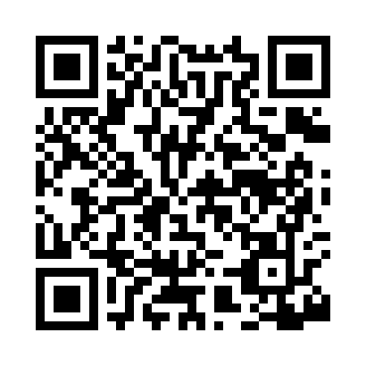
Prayer times for Balco, Louisiana, USA
Sat 1 Jun 2024 - Sun 30 Jun 2024
High Latitude Method: Angle Based Rule
Prayer Calculation Method: Islamic Society of North America
Asar Calculation Method: Shafi

Date | Day | Fajr | Sunrise | Dhuhr | Asr | Maghrib | Isha
1 | Sat | 4:49 | 6:06 | 1:04 | 4:39 | 8:02 | 9:19
2 | Sun | 4:49 | 6:05 | 1:04 | 4:39 | 8:03 | 9:19
3 | Mon | 4:48 | 6:05 | 1:04 | 4:39 | 8:03 | 9:20
4 | Tue | 4:48 | 6:05 | 1:04 | 4:39 | 8:03 | 9:21
5 | Wed | 4:48 | 6:05 | 1:04 | 4:39 | 8:04 | 9:21
6 | Thu | 4:48 | 6:05 | 1:05 | 4:40 | 8:04 | 9:22
7 | Fri | 4:48 | 6:05 | 1:05 | 4:40 | 8:05 | 9:22
8 | Sat | 4:47 | 6:05 | 1:05 | 4:40 | 8:05 | 9:23
9 | Sun | 4:47 | 6:05 | 1:05 | 4:40 | 8:06 | 9:23
10 | Mon | 4:47 | 6:05 | 1:05 | 4:40 | 8:06 | 9:24
11 | Tue | 4:47 | 6:05 | 1:06 | 4:40 | 8:07 | 9:24
12 | Wed | 4:47 | 6:05 | 1:06 | 4:41 | 8:07 | 9:25
13 | Thu | 4:47 | 6:05 | 1:06 | 4:41 | 8:07 | 9:25
14 | Fri | 4:47 | 6:05 | 1:06 | 4:41 | 8:08 | 9:25
15 | Sat | 4:47 | 6:05 | 1:06 | 4:41 | 8:08 | 9:26
16 | Sun | 4:47 | 6:05 | 1:07 | 4:41 | 8:08 | 9:26
17 | Mon | 4:47 | 6:05 | 1:07 | 4:42 | 8:08 | 9:26
18 | Tue | 4:47 | 6:05 | 1:07 | 4:42 | 8:09 | 9:27
19 | Wed | 4:48 | 6:06 | 1:07 | 4:42 | 8:09 | 9:27
20 | Thu | 4:48 | 6:06 | 1:08 | 4:42 | 8:09 | 9:27
21 | Fri | 4:48 | 6:06 | 1:08 | 4:42 | 8:09 | 9:27
22 | Sat | 4:48 | 6:06 | 1:08 | 4:43 | 8:10 | 9:28
23 | Sun | 4:49 | 6:07 | 1:08 | 4:43 | 8:10 | 9:28
24 | Mon | 4:49 | 6:07 | 1:08 | 4:43 | 8:10 | 9:28
25 | Tue | 4:49 | 6:07 | 1:09 | 4:43 | 8:10 | 9:28
26 | Wed | 4:50 | 6:07 | 1:09 | 4:44 | 8:10 | 9:28
27 | Thu | 4:50 | 6:08 | 1:09 | 4:44 | 8:10 | 9:28
28 | Fri | 4:50 | 6:08 | 1:09 | 4:44 | 8:10 | 9:28
29 | Sat | 4:51 | 6:08 | 1:09 | 4:44 | 8:10 | 9:28
30 | Sun | 4:51 | 6:09 | 1:10 | 4:44 | 8:10 | 9:28
Prayer times provided by https://www.salahtimes.com

