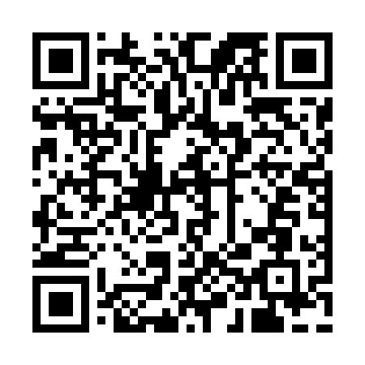

**Prayer times for Mont des Bruyeres, France**

**Sun 1 Sep 2024 - Mon 30 Sep 2024**

**High Latitude Method: Angle Based Rule**

**Prayer Calculation Method: Islamic Organisations Union of France**

**Asar Calculation Method: Shafi**

|  |  |  |  |  |  |  |  |
| --- | --- | --- | --- | --- | --- | --- | --- |
| **Date** | **Day** | **Fajr** | **Sunrise** | **Dhuhr** | **Asr** | **Maghrib** | **Isha** |
| 1 | Sun | 5:46 | 7:01 | 1:46 | 5:29 | 8:30 | 9:45 |
| 2 | Mon | 5:47 | 7:03 | 1:46 | 5:27 | 8:28 | 9:43 |
| 3 | Tue | 5:49 | 7:04 | 1:45 | 5:26 | 8:26 | 9:40 |
| 4 | Wed | 5:51 | 7:06 | 1:45 | 5:25 | 8:23 | 9:38 |
| 5 | Thu | 5:53 | 7:07 | 1:45 | 5:23 | 8:21 | 9:35 |
| 6 | Fri | 5:55 | 7:09 | 1:44 | 5:22 | 8:19 | 9:33 |
| 7 | Sat | 5:56 | 7:10 | 1:44 | 5:20 | 8:17 | 9:31 |
| 8 | Sun | 5:58 | 7:12 | 1:44 | 5:19 | 8:15 | 9:28 |
| 9 | Mon | 6:00 | 7:13 | 1:43 | 5:17 | 8:12 | 9:26 |
| 10 | Tue | 6:02 | 7:15 | 1:43 | 5:16 | 8:10 | 9:23 |
| 11 | Wed | 6:03 | 7:16 | 1:43 | 5:14 | 8:08 | 9:21 |
| 12 | Thu | 6:05 | 7:18 | 1:42 | 5:13 | 8:06 | 9:18 |
| 13 | Fri | 6:07 | 7:19 | 1:42 | 5:11 | 8:04 | 9:16 |
| 14 | Sat | 6:09 | 7:21 | 1:42 | 5:10 | 8:01 | 9:13 |
| 15 | Sun | 6:10 | 7:22 | 1:41 | 5:08 | 7:59 | 9:11 |
| 16 | Mon | 6:12 | 7:24 | 1:41 | 5:07 | 7:57 | 9:09 |
| 17 | Tue | 6:14 | 7:25 | 1:40 | 5:05 | 7:55 | 9:06 |
| 18 | Wed | 6:15 | 7:27 | 1:40 | 5:04 | 7:52 | 9:04 |
| 19 | Thu | 6:17 | 7:28 | 1:40 | 5:02 | 7:50 | 9:01 |
| 20 | Fri | 6:19 | 7:30 | 1:39 | 5:01 | 7:48 | 8:59 |
| 21 | Sat | 6:20 | 7:32 | 1:39 | 4:59 | 7:46 | 8:57 |
| 22 | Sun | 6:22 | 7:33 | 1:39 | 4:57 | 7:43 | 8:54 |
| 23 | Mon | 6:24 | 7:35 | 1:38 | 4:56 | 7:41 | 8:52 |
| 24 | Tue | 6:25 | 7:36 | 1:38 | 4:54 | 7:39 | 8:50 |
| 25 | Wed | 6:27 | 7:38 | 1:38 | 4:53 | 7:37 | 8:47 |
| 26 | Thu | 6:28 | 7:39 | 1:37 | 4:51 | 7:35 | 8:45 |
| 27 | Fri | 6:30 | 7:41 | 1:37 | 4:49 | 7:32 | 8:43 |
| 28 | Sat | 6:32 | 7:42 | 1:37 | 4:48 | 7:30 | 8:41 |
| 29 | Sun | 6:33 | 7:44 | 1:36 | 4:46 | 7:28 | 8:38 |
| 30 | Mon | 6:35 | 7:45 | 1:36 | 4:44 | 7:26 | 8:36 |

**Prayer times provided by https://www.salahtimes.com**