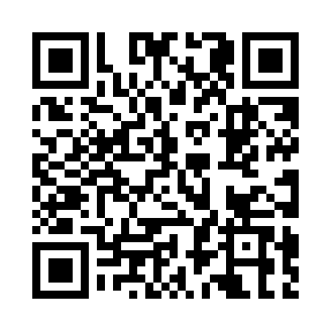

**Prayer times for Nizhnekamsk, Russia**

**Wed 1 Jan 2025 - Fri 31 Jan 2025**

**High Latitude Method: Angle Based Rule**

**Prayer Calculation Method: Spiritual Administration of Muslims of Russia**

**Asar Calculation Method: Shafi**

|  |  |  |  |  |  |  |  |
| --- | --- | --- | --- | --- | --- | --- | --- |
| **Date** | **Day** | **Fajr** | **Sunrise** | **Dhuhr** | **Asr** | **Maghrib** | **Isha** |
| 1 | Wed | 5:57 | 8:02 | 11:36 | 12:57 | 3:12 | 5:09 |
| 2 | Thu | 5:57 | 8:01 | 11:37 | 12:58 | 3:13 | 5:10 |
| 3 | Fri | 5:57 | 8:01 | 11:37 | 1:00 | 3:14 | 5:11 |
| 4 | Sat | 5:57 | 8:01 | 11:38 | 1:01 | 3:15 | 5:12 |
| 5 | Sun | 5:56 | 8:00 | 11:38 | 1:02 | 3:17 | 5:13 |
| 6 | Mon | 5:56 | 7:59 | 11:39 | 1:03 | 3:18 | 5:14 |
| 7 | Tue | 5:56 | 7:59 | 11:39 | 1:04 | 3:20 | 5:15 |
| 8 | Wed | 5:55 | 7:58 | 11:39 | 1:05 | 3:21 | 5:17 |
| 9 | Thu | 5:55 | 7:57 | 11:40 | 1:07 | 3:23 | 5:18 |
| 10 | Fri | 5:55 | 7:57 | 11:40 | 1:08 | 3:25 | 5:19 |
| 11 | Sat | 5:54 | 7:56 | 11:41 | 1:09 | 3:26 | 5:21 |
| 12 | Sun | 5:53 | 7:55 | 11:41 | 1:11 | 3:28 | 5:22 |
| 13 | Mon | 5:53 | 7:54 | 11:41 | 1:12 | 3:30 | 5:23 |
| 14 | Tue | 5:52 | 7:53 | 11:42 | 1:13 | 3:31 | 5:25 |
| 15 | Wed | 5:51 | 7:52 | 11:42 | 1:15 | 3:33 | 5:26 |
| 16 | Thu | 5:51 | 7:51 | 11:43 | 1:16 | 3:35 | 5:28 |
| 17 | Fri | 5:50 | 7:50 | 11:43 | 1:18 | 3:37 | 5:29 |
| 18 | Sat | 5:49 | 7:48 | 11:43 | 1:19 | 3:39 | 5:31 |
| 19 | Sun | 5:48 | 7:47 | 11:43 | 1:21 | 3:41 | 5:32 |
| 20 | Mon | 5:47 | 7:46 | 11:44 | 1:22 | 3:43 | 5:34 |
| 21 | Tue | 5:46 | 7:44 | 11:44 | 1:24 | 3:45 | 5:35 |
| 22 | Wed | 5:45 | 7:43 | 11:44 | 1:25 | 3:47 | 5:37 |
| 23 | Thu | 5:44 | 7:41 | 11:45 | 1:27 | 3:49 | 5:39 |
| 24 | Fri | 5:43 | 7:40 | 11:45 | 1:29 | 3:51 | 5:40 |
| 25 | Sat | 5:42 | 7:38 | 11:45 | 1:30 | 3:53 | 5:42 |
| 26 | Sun | 5:40 | 7:37 | 11:45 | 1:32 | 3:55 | 5:44 |
| 27 | Mon | 5:39 | 7:35 | 11:45 | 1:33 | 3:57 | 5:45 |
| 28 | Tue | 5:38 | 7:33 | 11:46 | 1:35 | 3:59 | 5:47 |
| 29 | Wed | 5:36 | 7:31 | 11:46 | 1:37 | 4:01 | 5:49 |
| 30 | Thu | 5:35 | 7:30 | 11:46 | 1:38 | 4:03 | 5:51 |
| 31 | Fri | 5:34 | 7:28 | 11:46 | 1:40 | 4:05 | 5:52 |

**Prayer times provided by https://www.salahtimes.com**