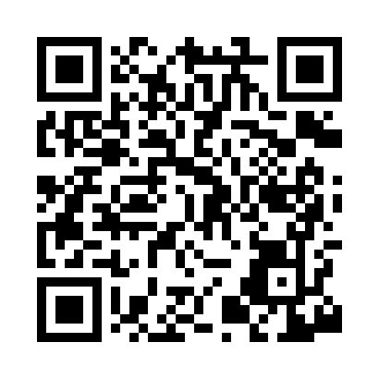
Prayer times for Cornatzer, North Carolina, USA
Wed 1 May 2024 - Fri 31 May 2024
High Latitude Method: Angle Based Rule
Prayer Calculation Method: Islamic Society of North America
Asar Calculation Method: Shafi

Date | Day | Fajr | Sunrise | Dhuhr | Asr | Maghrib | Isha
1 | Wed | 5:11 | 6:29 | 1:19 | 5:04 | 8:10 | 9:27
2 | Thu | 5:10 | 6:28 | 1:19 | 5:04 | 8:10 | 9:29
3 | Fri | 5:08 | 6:27 | 1:19 | 5:05 | 8:11 | 9:30
4 | Sat | 5:07 | 6:26 | 1:19 | 5:05 | 8:12 | 9:31
5 | Sun | 5:06 | 6:25 | 1:19 | 5:05 | 8:13 | 9:32
6 | Mon | 5:05 | 6:24 | 1:19 | 5:05 | 8:14 | 9:33
7 | Tue | 5:03 | 6:23 | 1:18 | 5:05 | 8:15 | 9:34
8 | Wed | 5:02 | 6:22 | 1:18 | 5:05 | 8:15 | 9:35
9 | Thu | 5:01 | 6:21 | 1:18 | 5:05 | 8:16 | 9:36
10 | Fri | 5:00 | 6:20 | 1:18 | 5:06 | 8:17 | 9:37
11 | Sat | 4:59 | 6:19 | 1:18 | 5:06 | 8:18 | 9:39
12 | Sun | 4:57 | 6:18 | 1:18 | 5:06 | 8:19 | 9:40
13 | Mon | 4:56 | 6:17 | 1:18 | 5:06 | 8:20 | 9:41
14 | Tue | 4:55 | 6:17 | 1:18 | 5:06 | 8:20 | 9:42
15 | Wed | 4:54 | 6:16 | 1:18 | 5:06 | 8:21 | 9:43
16 | Thu | 4:53 | 6:15 | 1:18 | 5:06 | 8:22 | 9:44
17 | Fri | 4:52 | 6:14 | 1:18 | 5:07 | 8:23 | 9:45
18 | Sat | 4:51 | 6:14 | 1:18 | 5:07 | 8:24 | 9:46
19 | Sun | 4:50 | 6:13 | 1:18 | 5:07 | 8:24 | 9:47
20 | Mon | 4:49 | 6:12 | 1:19 | 5:07 | 8:25 | 9:48
21 | Tue | 4:48 | 6:12 | 1:19 | 5:07 | 8:26 | 9:49
22 | Wed | 4:48 | 6:11 | 1:19 | 5:07 | 8:27 | 9:50
23 | Thu | 4:47 | 6:11 | 1:19 | 5:07 | 8:27 | 9:51
24 | Fri | 4:46 | 6:10 | 1:19 | 5:08 | 8:28 | 9:52
25 | Sat | 4:45 | 6:09 | 1:19 | 5:08 | 8:29 | 9:53
26 | Sun | 4:44 | 6:09 | 1:19 | 5:08 | 8:29 | 9:54
27 | Mon | 4:44 | 6:08 | 1:19 | 5:08 | 8:30 | 9:55
28 | Tue | 4:43 | 6:08 | 1:19 | 5:08 | 8:31 | 9:56
29 | Wed | 4:42 | 6:08 | 1:19 | 5:09 | 8:32 | 9:57
30 | Thu | 4:42 | 6:07 | 1:20 | 5:09 | 8:32 | 9:58
31 | Fri | 4:41 | 6:07 | 1:20 | 5:09 | 8:33 | 9:59
Prayer times provided by https://www.salahtimes.com

