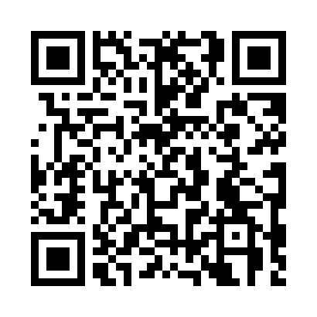
Prayer times for Arqusiugaq, Quebec, Canada
Mon 1 Jul 2024 - Wed 31 Jul 2024
High Latitude Method: Angle Based Rule
Prayer Calculation Method: Islamic Society of North America
Asar Calculation Method: Hanafi

Date | Day | Fajr | Sunrise | Dhuhr | Asr | Maghrib | Isha
1 | Mon | 1:59 | 3:16 | 12:43 | 6:44 | 10:10 | 11:26
2 | Tue | 2:00 | 3:17 | 12:43 | 6:43 | 10:09 | 11:26
3 | Wed | 2:01 | 3:18 | 12:43 | 6:43 | 10:08 | 11:26
4 | Thu | 2:01 | 3:20 | 12:44 | 6:43 | 10:07 | 11:25
5 | Fri | 2:02 | 3:21 | 12:44 | 6:42 | 10:06 | 11:25
6 | Sat | 2:03 | 3:23 | 12:44 | 6:42 | 10:05 | 11:24
7 | Sun | 2:04 | 3:24 | 12:44 | 6:41 | 10:03 | 11:24
8 | Mon | 2:05 | 3:26 | 12:44 | 6:41 | 10:02 | 11:23
9 | Tue | 2:06 | 3:28 | 12:44 | 6:40 | 10:00 | 11:22
10 | Wed | 2:07 | 3:29 | 12:45 | 6:40 | 9:59 | 11:22
11 | Thu | 2:08 | 3:31 | 12:45 | 6:39 | 9:57 | 11:21
12 | Fri | 2:09 | 3:33 | 12:45 | 6:39 | 9:56 | 11:20
13 | Sat | 2:10 | 3:35 | 12:45 | 6:38 | 9:54 | 11:19
14 | Sun | 2:11 | 3:37 | 12:45 | 6:37 | 9:52 | 11:18
15 | Mon | 2:12 | 3:39 | 12:45 | 6:36 | 9:50 | 11:18
16 | Tue | 2:13 | 3:41 | 12:45 | 6:35 | 9:48 | 11:17
17 | Wed | 2:14 | 3:43 | 12:45 | 6:35 | 9:47 | 11:16
18 | Thu | 2:15 | 3:45 | 12:45 | 6:34 | 9:45 | 11:15
19 | Fri | 2:16 | 3:47 | 12:45 | 6:33 | 9:42 | 11:14
20 | Sat | 2:17 | 3:50 | 12:45 | 6:32 | 9:40 | 11:13
21 | Sun | 2:18 | 3:52 | 12:46 | 6:31 | 9:38 | 11:12
22 | Mon | 2:19 | 3:54 | 12:46 | 6:30 | 9:36 | 11:10
23 | Tue | 2:21 | 3:56 | 12:46 | 6:29 | 9:34 | 11:09
24 | Wed | 2:22 | 3:59 | 12:46 | 6:27 | 9:31 | 11:08
25 | Thu | 2:23 | 4:01 | 12:46 | 6:26 | 9:29 | 11:07
26 | Fri | 2:24 | 4:03 | 12:46 | 6:25 | 9:27 | 11:06
27 | Sat | 2:25 | 4:06 | 12:46 | 6:24 | 9:24 | 11:05
28 | Sun | 2:26 | 4:08 | 12:46 | 6:22 | 9:22 | 11:03
29 | Mon | 2:28 | 4:10 | 12:46 | 6:21 | 9:19 | 11:02
30 | Tue | 2:29 | 4:13 | 12:45 | 6:20 | 9:17 | 11:01
31 | Wed | 2:30 | 4:15 | 12:45 | 6:18 | 9:14 | 11:00
Prayer times provided by https://www.salahtimes.com

