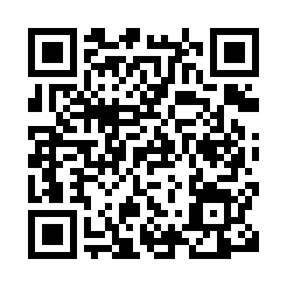
Prayer times for Am Turm, Germany
Wed 1 May 2024 - Fri 31 May 2024
High Latitude Method: Angle Based Rule
Prayer Calculation Method: Muslim World League
Asar Calculation Method: Shafi

Date | Day | Fajr | Sunrise | Dhuhr | Asr | Maghrib | Isha
1 | Wed | 3:57 | 6:08 | 1:24 | 5:24 | 8:42 | 10:44
2 | Thu | 3:54 | 6:06 | 1:24 | 5:25 | 8:43 | 10:46
3 | Fri | 3:51 | 6:04 | 1:24 | 5:25 | 8:44 | 10:48
4 | Sat | 3:49 | 6:03 | 1:24 | 5:26 | 8:46 | 10:51
5 | Sun | 3:46 | 6:01 | 1:24 | 5:26 | 8:47 | 10:53
6 | Mon | 3:43 | 6:00 | 1:24 | 5:27 | 8:49 | 10:56
7 | Tue | 3:41 | 5:58 | 1:24 | 5:27 | 8:50 | 10:58
8 | Wed | 3:38 | 5:57 | 1:24 | 5:28 | 8:51 | 11:00
9 | Thu | 3:35 | 5:55 | 1:24 | 5:28 | 8:53 | 11:03
10 | Fri | 3:32 | 5:54 | 1:24 | 5:29 | 8:54 | 11:05
11 | Sat | 3:30 | 5:52 | 1:24 | 5:29 | 8:56 | 11:08
12 | Sun | 3:27 | 5:51 | 1:24 | 5:30 | 8:57 | 11:10
13 | Mon | 3:24 | 5:50 | 1:24 | 5:30 | 8:58 | 11:13
14 | Tue | 3:21 | 5:48 | 1:24 | 5:31 | 9:00 | 11:15
15 | Wed | 3:19 | 5:47 | 1:24 | 5:31 | 9:01 | 11:18
16 | Thu | 3:16 | 5:46 | 1:24 | 5:32 | 9:02 | 11:20
17 | Fri | 3:13 | 5:45 | 1:24 | 5:32 | 9:03 | 11:23
18 | Sat | 3:10 | 5:43 | 1:24 | 5:33 | 9:05 | 11:26
19 | Sun | 3:08 | 5:42 | 1:24 | 5:33 | 9:06 | 11:28
20 | Mon | 3:07 | 5:41 | 1:24 | 5:34 | 9:07 | 11:31
21 | Tue | 3:06 | 5:40 | 1:24 | 5:34 | 9:08 | 11:33
22 | Wed | 3:06 | 5:39 | 1:24 | 5:35 | 9:10 | 11:34
23 | Thu | 3:06 | 5:38 | 1:24 | 5:35 | 9:11 | 11:34
24 | Fri | 3:05 | 5:37 | 1:24 | 5:35 | 9:12 | 11:35
25 | Sat | 3:05 | 5:36 | 1:24 | 5:36 | 9:13 | 11:35
26 | Sun | 3:05 | 5:35 | 1:24 | 5:36 | 9:14 | 11:36
27 | Mon | 3:05 | 5:34 | 1:24 | 5:37 | 9:15 | 11:37
28 | Tue | 3:04 | 5:33 | 1:25 | 5:37 | 9:16 | 11:37
29 | Wed | 3:04 | 5:33 | 1:25 | 5:38 | 9:17 | 11:38
30 | Thu | 3:04 | 5:32 | 1:25 | 5:38 | 9:18 | 11:38
31 | Fri | 3:04 | 5:31 | 1:25 | 5:38 | 9:19 | 11:39
Prayer times provided by https://www.salahtimes.com

