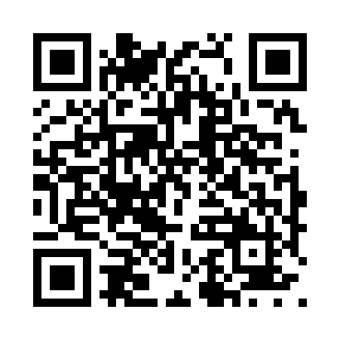

**Prayer times for Solikamsk, Russia**

**Wed 1 Jan 2025 - Fri 31 Jan 2025**

**High Latitude Method: Angle Based Rule**

**Prayer Calculation Method: Spiritual Administration of Muslims of Russia**

**Asar Calculation Method: Shafi**

|  |  |  |  |  |  |  |  |
| --- | --- | --- | --- | --- | --- | --- | --- |
| **Date** | **Day** | **Fajr** | **Sunrise** | **Dhuhr** | **Asr** | **Maghrib** | **Isha** |
| 1 | Wed | 7:47 | 10:12 | 1:17 | 2:14 | 4:22 | 6:38 |
| 2 | Thu | 7:47 | 10:11 | 1:17 | 2:15 | 4:23 | 6:40 |
| 3 | Fri | 7:46 | 10:11 | 1:18 | 2:17 | 4:25 | 6:41 |
| 4 | Sat | 7:46 | 10:10 | 1:18 | 2:18 | 4:27 | 6:42 |
| 5 | Sun | 7:46 | 10:09 | 1:18 | 2:19 | 4:28 | 6:43 |
| 6 | Mon | 7:45 | 10:08 | 1:19 | 2:20 | 4:30 | 6:44 |
| 7 | Tue | 7:45 | 10:08 | 1:19 | 2:22 | 4:32 | 6:46 |
| 8 | Wed | 7:44 | 10:07 | 1:20 | 2:23 | 4:34 | 6:47 |
| 9 | Thu | 7:44 | 10:06 | 1:20 | 2:24 | 4:36 | 6:49 |
| 10 | Fri | 7:43 | 10:04 | 1:21 | 2:26 | 4:38 | 6:50 |
| 11 | Sat | 7:43 | 10:03 | 1:21 | 2:27 | 4:40 | 6:52 |
| 12 | Sun | 7:42 | 10:02 | 1:21 | 2:29 | 4:42 | 6:53 |
| 13 | Mon | 7:41 | 10:01 | 1:22 | 2:30 | 4:44 | 6:55 |
| 14 | Tue | 7:40 | 9:59 | 1:22 | 2:32 | 4:46 | 6:56 |
| 15 | Wed | 7:39 | 9:58 | 1:22 | 2:33 | 4:48 | 6:58 |
| 16 | Thu | 7:38 | 9:56 | 1:23 | 2:35 | 4:50 | 7:00 |
| 17 | Fri | 7:37 | 9:55 | 1:23 | 2:37 | 4:53 | 7:01 |
| 18 | Sat | 7:36 | 9:53 | 1:23 | 2:38 | 4:55 | 7:03 |
| 19 | Sun | 7:35 | 9:51 | 1:24 | 2:40 | 4:57 | 7:05 |
| 20 | Mon | 7:34 | 9:50 | 1:24 | 2:42 | 5:00 | 7:07 |
| 21 | Tue | 7:33 | 9:48 | 1:24 | 2:44 | 5:02 | 7:09 |
| 22 | Wed | 7:31 | 9:46 | 1:25 | 2:45 | 5:04 | 7:10 |
| 23 | Thu | 7:30 | 9:44 | 1:25 | 2:47 | 5:07 | 7:12 |
| 24 | Fri | 7:29 | 9:42 | 1:25 | 2:49 | 5:09 | 7:14 |
| 25 | Sat | 7:27 | 9:40 | 1:25 | 2:51 | 5:12 | 7:16 |
| 26 | Sun | 7:26 | 9:38 | 1:26 | 2:53 | 5:14 | 7:18 |
| 27 | Mon | 7:24 | 9:36 | 1:26 | 2:54 | 5:17 | 7:20 |
| 28 | Tue | 7:23 | 9:34 | 1:26 | 2:56 | 5:19 | 7:22 |
| 29 | Wed | 7:21 | 9:32 | 1:26 | 2:58 | 5:22 | 7:24 |
| 30 | Thu | 7:19 | 9:29 | 1:26 | 3:00 | 5:24 | 7:26 |
| 31 | Fri | 7:18 | 9:27 | 1:26 | 3:02 | 5:27 | 7:28 |

**Prayer times provided by https://www.salahtimes.com**