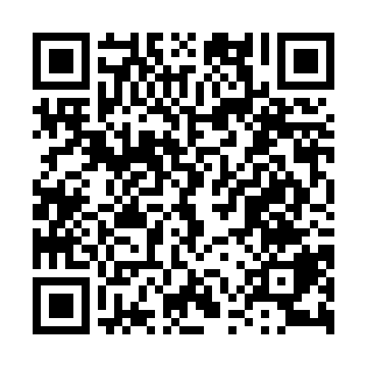
Prayer times for Santiago de Cuba, Cuba
Wed 1 May 2024 - Fri 31 May 2024
High Latitude Method: None
Prayer Calculation Method: Muslim World League
Asar Calculation Method: Shafi

Date | Day | Fajr | Sunrise | Dhuhr | Asr | Maghrib | Isha
1 | Wed | 5:16 | 6:34 | 1:00 | 4:18 | 7:27 | 8:40
2 | Thu | 5:15 | 6:33 | 1:00 | 4:18 | 7:27 | 8:41
3 | Fri | 5:14 | 6:33 | 1:00 | 4:17 | 7:28 | 8:41
4 | Sat | 5:13 | 6:32 | 1:00 | 4:17 | 7:28 | 8:42
5 | Sun | 5:13 | 6:31 | 1:00 | 4:17 | 7:29 | 8:43
6 | Mon | 5:12 | 6:31 | 1:00 | 4:16 | 7:29 | 8:43
7 | Tue | 5:11 | 6:30 | 1:00 | 4:16 | 7:29 | 8:44
8 | Wed | 5:11 | 6:30 | 1:00 | 4:16 | 7:30 | 8:44
9 | Thu | 5:10 | 6:29 | 1:00 | 4:15 | 7:30 | 8:45
10 | Fri | 5:09 | 6:29 | 1:00 | 4:15 | 7:30 | 8:45
11 | Sat | 5:09 | 6:29 | 1:00 | 4:14 | 7:31 | 8:46
12 | Sun | 5:08 | 6:28 | 1:00 | 4:14 | 7:31 | 8:46
13 | Mon | 5:08 | 6:28 | 1:00 | 4:14 | 7:32 | 8:47
14 | Tue | 5:07 | 6:27 | 1:00 | 4:13 | 7:32 | 8:48
15 | Wed | 5:07 | 6:27 | 1:00 | 4:13 | 7:32 | 8:48
16 | Thu | 5:06 | 6:27 | 1:00 | 4:13 | 7:33 | 8:49
17 | Fri | 5:05 | 6:26 | 1:00 | 4:13 | 7:33 | 8:49
18 | Sat | 5:05 | 6:26 | 1:00 | 4:12 | 7:34 | 8:50
19 | Sun | 5:05 | 6:26 | 1:00 | 4:12 | 7:34 | 8:50
20 | Mon | 5:04 | 6:25 | 1:00 | 4:13 | 7:34 | 8:51
21 | Tue | 5:04 | 6:25 | 1:00 | 4:13 | 7:35 | 8:51
22 | Wed | 5:03 | 6:25 | 1:00 | 4:14 | 7:35 | 8:52
23 | Thu | 5:03 | 6:24 | 1:00 | 4:14 | 7:36 | 8:53
24 | Fri | 5:02 | 6:24 | 1:00 | 4:15 | 7:36 | 8:53
25 | Sat | 5:02 | 6:24 | 1:00 | 4:16 | 7:37 | 8:54
26 | Sun | 5:02 | 6:24 | 1:00 | 4:16 | 7:37 | 8:54
27 | Mon | 5:01 | 6:24 | 1:00 | 4:17 | 7:37 | 8:55
28 | Tue | 5:01 | 6:24 | 1:01 | 4:17 | 7:38 | 8:55
29 | Wed | 5:01 | 6:23 | 1:01 | 4:18 | 7:38 | 8:56
30 | Thu | 5:01 | 6:23 | 1:01 | 4:18 | 7:39 | 8:56
31 | Fri | 5:00 | 6:23 | 1:01 | 4:19 | 7:39 | 8:57
Prayer times provided by https://www.salahtimes.com

