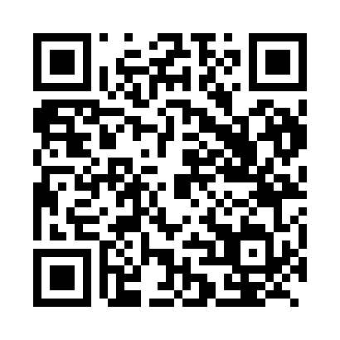
Prayer times for Biba I, Cameroon
Wed 1 May 2024 - Fri 31 May 2024
High Latitude Method: None
Prayer Calculation Method: Muslim World League
Asar Calculation Method: Shafi

Date | Day | Fajr | Sunrise | Dhuhr | Asr | Maghrib | Isha
1 | Wed | 4:44 | 5:56 | 12:02 | 3:22 | 6:09 | 7:16
2 | Thu | 4:44 | 5:55 | 12:02 | 3:22 | 6:09 | 7:17
3 | Fri | 4:43 | 5:55 | 12:02 | 3:22 | 6:09 | 7:17
4 | Sat | 4:43 | 5:55 | 12:02 | 3:22 | 6:09 | 7:17
5 | Sun | 4:43 | 5:55 | 12:02 | 3:23 | 6:09 | 7:17
6 | Mon | 4:43 | 5:55 | 12:02 | 3:23 | 6:09 | 7:17
7 | Tue | 4:42 | 5:55 | 12:02 | 3:23 | 6:09 | 7:17
8 | Wed | 4:42 | 5:55 | 12:02 | 3:23 | 6:09 | 7:17
9 | Thu | 4:42 | 5:54 | 12:02 | 3:24 | 6:09 | 7:17
10 | Fri | 4:42 | 5:54 | 12:02 | 3:24 | 6:09 | 7:17
11 | Sat | 4:42 | 5:54 | 12:02 | 3:24 | 6:09 | 7:18
12 | Sun | 4:41 | 5:54 | 12:02 | 3:24 | 6:09 | 7:18
13 | Mon | 4:41 | 5:54 | 12:02 | 3:24 | 6:09 | 7:18
14 | Tue | 4:41 | 5:54 | 12:02 | 3:25 | 6:09 | 7:18
15 | Wed | 4:41 | 5:54 | 12:02 | 3:25 | 6:09 | 7:18
16 | Thu | 4:41 | 5:54 | 12:02 | 3:25 | 6:09 | 7:18
17 | Fri | 4:41 | 5:54 | 12:02 | 3:25 | 6:10 | 7:19
18 | Sat | 4:40 | 5:54 | 12:02 | 3:26 | 6:10 | 7:19
19 | Sun | 4:40 | 5:54 | 12:02 | 3:26 | 6:10 | 7:19
20 | Mon | 4:40 | 5:54 | 12:02 | 3:26 | 6:10 | 7:19
21 | Tue | 4:40 | 5:54 | 12:02 | 3:26 | 6:10 | 7:19
22 | Wed | 4:40 | 5:54 | 12:02 | 3:27 | 6:10 | 7:20
23 | Thu | 4:40 | 5:54 | 12:02 | 3:27 | 6:10 | 7:20
24 | Fri | 4:40 | 5:54 | 12:02 | 3:27 | 6:10 | 7:20
25 | Sat | 4:40 | 5:54 | 12:02 | 3:27 | 6:11 | 7:20
26 | Sun | 4:40 | 5:54 | 12:02 | 3:28 | 6:11 | 7:21
27 | Mon | 4:40 | 5:54 | 12:02 | 3:28 | 6:11 | 7:21
28 | Tue | 4:40 | 5:54 | 12:03 | 3:28 | 6:11 | 7:21
29 | Wed | 4:40 | 5:54 | 12:03 | 3:28 | 6:11 | 7:21
30 | Thu | 4:40 | 5:54 | 12:03 | 3:29 | 6:11 | 7:22
31 | Fri | 4:40 | 5:55 | 12:03 | 3:29 | 6:12 | 7:22
Prayer times provided by https://www.salahtimes.com

