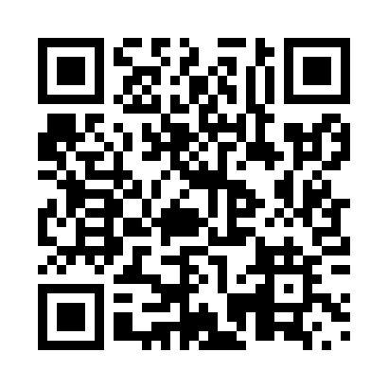

**Prayer times for Liard River, British Columbia, Canada**

**Sun 1 Sep 2024 - Mon 30 Sep 2024**

**High Latitude Method: Angle Based Rule**

**Prayer Calculation Method: Islamic Society of North America**

**Asar Calculation Method: Hanafi**

|  |  |  |  |  |  |  |  |
| --- | --- | --- | --- | --- | --- | --- | --- |
| **Date** | **Day** | **Fajr** | **Sunrise** | **Dhuhr** | **Asr** | **Maghrib** | **Isha** |
| 1 | Sun | 4:10 | 6:23 | 1:24 | 6:02 | 8:24 | 10:36 |
| 2 | Mon | 4:13 | 6:25 | 1:24 | 6:00 | 8:21 | 10:32 |
| 3 | Tue | 4:17 | 6:27 | 1:23 | 5:58 | 8:18 | 10:28 |
| 4 | Wed | 4:20 | 6:29 | 1:23 | 5:56 | 8:15 | 10:24 |
| 5 | Thu | 4:24 | 6:32 | 1:23 | 5:53 | 8:12 | 10:20 |
| 6 | Fri | 4:27 | 6:34 | 1:22 | 5:51 | 8:09 | 10:16 |
| 7 | Sat | 4:30 | 6:36 | 1:22 | 5:49 | 8:06 | 10:12 |
| 8 | Sun | 4:34 | 6:39 | 1:22 | 5:46 | 8:04 | 10:08 |
| 9 | Mon | 4:37 | 6:41 | 1:21 | 5:44 | 8:01 | 10:04 |
| 10 | Tue | 4:40 | 6:43 | 1:21 | 5:42 | 7:58 | 10:00 |
| 11 | Wed | 4:43 | 6:45 | 1:21 | 5:39 | 7:55 | 9:57 |
| 12 | Thu | 4:46 | 6:48 | 1:20 | 5:37 | 7:52 | 9:53 |
| 13 | Fri | 4:49 | 6:50 | 1:20 | 5:35 | 7:49 | 9:49 |
| 14 | Sat | 4:52 | 6:52 | 1:20 | 5:32 | 7:46 | 9:45 |
| 15 | Sun | 4:55 | 6:55 | 1:19 | 5:30 | 7:43 | 9:42 |
| 16 | Mon | 4:58 | 6:57 | 1:19 | 5:27 | 7:40 | 9:38 |
| 17 | Tue | 5:01 | 6:59 | 1:19 | 5:25 | 7:37 | 9:35 |
| 18 | Wed | 5:04 | 7:01 | 1:18 | 5:22 | 7:34 | 9:31 |
| 19 | Thu | 5:06 | 7:04 | 1:18 | 5:20 | 7:31 | 9:28 |
| 20 | Fri | 5:09 | 7:06 | 1:17 | 5:17 | 7:28 | 9:24 |
| 21 | Sat | 5:12 | 7:08 | 1:17 | 5:15 | 7:25 | 9:21 |
| 22 | Sun | 5:15 | 7:10 | 1:17 | 5:12 | 7:22 | 9:17 |
| 23 | Mon | 5:17 | 7:13 | 1:16 | 5:10 | 7:19 | 9:14 |
| 24 | Tue | 5:20 | 7:15 | 1:16 | 5:07 | 7:16 | 9:10 |
| 25 | Wed | 5:23 | 7:17 | 1:16 | 5:05 | 7:13 | 9:07 |
| 26 | Thu | 5:25 | 7:20 | 1:15 | 5:02 | 7:10 | 9:04 |
| 27 | Fri | 5:28 | 7:22 | 1:15 | 5:00 | 7:07 | 9:01 |
| 28 | Sat | 5:30 | 7:24 | 1:15 | 4:57 | 7:04 | 8:57 |
| 29 | Sun | 5:33 | 7:27 | 1:14 | 4:54 | 7:01 | 8:54 |
| 30 | Mon | 5:36 | 7:29 | 1:14 | 4:52 | 6:58 | 8:51 |

**Prayer times provided by https://www.salahtimes.com**