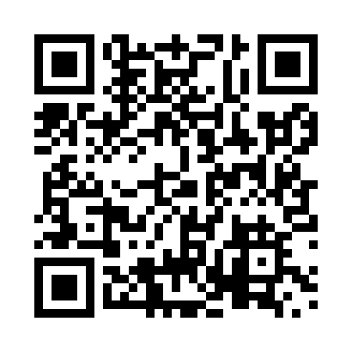
Prayer times for Bassano, Alberta, Canada
Mon 1 Apr 2024 - Tue 30 Apr 2024
High Latitude Method: Angle Based Rule
Prayer Calculation Method: Islamic Society of North America
Asar Calculation Method: Hanafi

Date | Day | Fajr | Sunrise | Dhuhr | Asr | Maghrib | Isha
1 | Mon | 5:30 | 7:04 | 1:34 | 6:01 | 8:04 | 9:39
2 | Tue | 5:27 | 7:02 | 1:33 | 6:03 | 8:05 | 9:41
3 | Wed | 5:24 | 7:00 | 1:33 | 6:04 | 8:07 | 9:43
4 | Thu | 5:22 | 6:58 | 1:33 | 6:05 | 8:09 | 9:45
5 | Fri | 5:19 | 6:55 | 1:32 | 6:06 | 8:10 | 9:47
6 | Sat | 5:17 | 6:53 | 1:32 | 6:07 | 8:12 | 9:49
7 | Sun | 5:14 | 6:51 | 1:32 | 6:08 | 8:13 | 9:51
8 | Mon | 5:11 | 6:49 | 1:32 | 6:10 | 8:15 | 9:53
9 | Tue | 5:09 | 6:47 | 1:31 | 6:11 | 8:17 | 9:55
10 | Wed | 5:06 | 6:45 | 1:31 | 6:12 | 8:18 | 9:57
11 | Thu | 5:03 | 6:42 | 1:31 | 6:13 | 8:20 | 9:59
12 | Fri | 5:01 | 6:40 | 1:30 | 6:14 | 8:22 | 10:01
13 | Sat | 4:58 | 6:38 | 1:30 | 6:15 | 8:23 | 10:04
14 | Sun | 4:55 | 6:36 | 1:30 | 6:16 | 8:25 | 10:06
15 | Mon | 4:53 | 6:34 | 1:30 | 6:17 | 8:26 | 10:08
16 | Tue | 4:50 | 6:32 | 1:29 | 6:18 | 8:28 | 10:10
17 | Wed | 4:47 | 6:30 | 1:29 | 6:19 | 8:30 | 10:13
18 | Thu | 4:45 | 6:28 | 1:29 | 6:20 | 8:31 | 10:15
19 | Fri | 4:42 | 6:26 | 1:29 | 6:22 | 8:33 | 10:17
20 | Sat | 4:39 | 6:24 | 1:29 | 6:23 | 8:34 | 10:19
21 | Sun | 4:36 | 6:22 | 1:28 | 6:24 | 8:36 | 10:22
22 | Mon | 4:34 | 6:20 | 1:28 | 6:25 | 8:38 | 10:24
23 | Tue | 4:31 | 6:18 | 1:28 | 6:26 | 8:39 | 10:27
24 | Wed | 4:28 | 6:16 | 1:28 | 6:27 | 8:41 | 10:29
25 | Thu | 4:25 | 6:14 | 1:28 | 6:28 | 8:43 | 10:31
26 | Fri | 4:23 | 6:12 | 1:28 | 6:29 | 8:44 | 10:34
27 | Sat | 4:20 | 6:10 | 1:27 | 6:30 | 8:46 | 10:36
28 | Sun | 4:17 | 6:08 | 1:27 | 6:31 | 8:47 | 10:39
29 | Mon | 4:15 | 6:06 | 1:27 | 6:32 | 8:49 | 10:41
30 | Tue | 4:12 | 6:04 | 1:27 | 6:33 | 8:50 | 10:44
Prayer times provided by https://www.salahtimes.com

