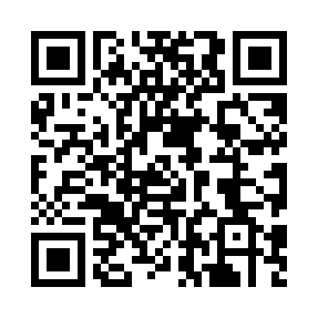

**Prayer times for Ekoko, Namibia**

**Sun 1 Dec 2024 - Tue 31 Dec 2024**

**High Latitude Method: None**

**Prayer Calculation Method: Muslim World League**

**Asar Calculation Method: Shafi**

|  |  |  |  |  |  |  |  |
| --- | --- | --- | --- | --- | --- | --- | --- |
| **Date** | **Day** | **Fajr** | **Sunrise** | **Dhuhr** | **Asr** | **Maghrib** | **Isha** |
| 1 | Sun | 4:47 | 6:08 | 12:41 | 4:01 | 7:15 | 8:31 |
| 2 | Mon | 4:47 | 6:08 | 12:41 | 4:02 | 7:15 | 8:31 |
| 3 | Tue | 4:47 | 6:08 | 12:42 | 4:02 | 7:16 | 8:32 |
| 4 | Wed | 4:47 | 6:08 | 12:42 | 4:03 | 7:16 | 8:33 |
| 5 | Thu | 4:47 | 6:08 | 12:43 | 4:04 | 7:17 | 8:34 |
| 6 | Fri | 4:47 | 6:09 | 12:43 | 4:05 | 7:18 | 8:34 |
| 7 | Sat | 4:47 | 6:09 | 12:44 | 4:05 | 7:18 | 8:35 |
| 8 | Sun | 4:47 | 6:09 | 12:44 | 4:06 | 7:19 | 8:36 |
| 9 | Mon | 4:48 | 6:09 | 12:44 | 4:07 | 7:19 | 8:36 |
| 10 | Tue | 4:48 | 6:10 | 12:45 | 4:07 | 7:20 | 8:37 |
| 11 | Wed | 4:48 | 6:10 | 12:45 | 4:08 | 7:21 | 8:38 |
| 12 | Thu | 4:48 | 6:10 | 12:46 | 4:09 | 7:21 | 8:38 |
| 13 | Fri | 4:49 | 6:11 | 12:46 | 4:09 | 7:22 | 8:39 |
| 14 | Sat | 4:49 | 6:11 | 12:47 | 4:10 | 7:22 | 8:39 |
| 15 | Sun | 4:49 | 6:12 | 12:47 | 4:10 | 7:23 | 8:40 |
| 16 | Mon | 4:50 | 6:12 | 12:48 | 4:11 | 7:23 | 8:41 |
| 17 | Tue | 4:50 | 6:12 | 12:48 | 4:11 | 7:24 | 8:41 |
| 18 | Wed | 4:51 | 6:13 | 12:49 | 4:12 | 7:25 | 8:42 |
| 19 | Thu | 4:51 | 6:13 | 12:49 | 4:13 | 7:25 | 8:42 |
| 20 | Fri | 4:51 | 6:14 | 12:50 | 4:13 | 7:26 | 8:43 |
| 21 | Sat | 4:52 | 6:14 | 12:50 | 4:14 | 7:26 | 8:43 |
| 22 | Sun | 4:52 | 6:15 | 12:51 | 4:14 | 7:27 | 8:44 |
| 23 | Mon | 4:53 | 6:15 | 12:51 | 4:15 | 7:27 | 8:44 |
| 24 | Tue | 4:54 | 6:16 | 12:52 | 4:15 | 7:27 | 8:45 |
| 25 | Wed | 4:54 | 6:16 | 12:52 | 4:15 | 7:28 | 8:45 |
| 26 | Thu | 4:55 | 6:17 | 12:53 | 4:16 | 7:28 | 8:46 |
| 27 | Fri | 4:55 | 6:17 | 12:53 | 4:16 | 7:29 | 8:46 |
| 28 | Sat | 4:56 | 6:18 | 12:54 | 4:17 | 7:29 | 8:46 |
| 29 | Sun | 4:56 | 6:19 | 12:54 | 4:17 | 7:30 | 8:47 |
| 30 | Mon | 4:57 | 6:19 | 12:55 | 4:17 | 7:30 | 8:47 |
| 31 | Tue | 4:58 | 6:20 | 12:55 | 4:18 | 7:30 | 8:47 |

**Prayer times provided by https://www.salahtimes.com**