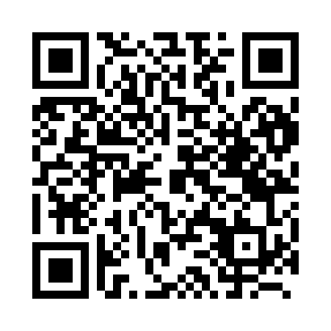
Prayer times for Barranco, Belize
Mon 1 Apr 2024 - Tue 30 Apr 2024
High Latitude Method: None
Prayer Calculation Method: Muslim World League
Asar Calculation Method: Shafi

Date | Day | Fajr | Sunrise | Dhuhr | Asr | Maghrib | Isha
1 | Mon | 4:38 | 5:50 | 11:59 | 3:19 | 6:09 | 7:16
2 | Tue | 4:37 | 5:50 | 11:59 | 3:18 | 6:09 | 7:17
3 | Wed | 4:37 | 5:49 | 11:59 | 3:18 | 6:09 | 7:17
4 | Thu | 4:36 | 5:48 | 11:58 | 3:17 | 6:09 | 7:17
5 | Fri | 4:35 | 5:47 | 11:58 | 3:16 | 6:09 | 7:17
6 | Sat | 4:34 | 5:47 | 11:58 | 3:16 | 6:09 | 7:18
7 | Sun | 4:33 | 5:46 | 11:58 | 3:15 | 6:09 | 7:18
8 | Mon | 4:33 | 5:45 | 11:57 | 3:15 | 6:10 | 7:18
9 | Tue | 4:32 | 5:45 | 11:57 | 3:14 | 6:10 | 7:18
10 | Wed | 4:31 | 5:44 | 11:57 | 3:14 | 6:10 | 7:19
11 | Thu | 4:30 | 5:43 | 11:57 | 3:13 | 6:10 | 7:19
12 | Fri | 4:29 | 5:42 | 11:56 | 3:12 | 6:10 | 7:19
13 | Sat | 4:29 | 5:42 | 11:56 | 3:12 | 6:10 | 7:19
14 | Sun | 4:28 | 5:41 | 11:56 | 3:11 | 6:11 | 7:20
15 | Mon | 4:27 | 5:40 | 11:56 | 3:11 | 6:11 | 7:20
16 | Tue | 4:26 | 5:40 | 11:55 | 3:10 | 6:11 | 7:20
17 | Wed | 4:25 | 5:39 | 11:55 | 3:10 | 6:11 | 7:21
18 | Thu | 4:25 | 5:38 | 11:55 | 3:09 | 6:11 | 7:21
19 | Fri | 4:24 | 5:38 | 11:55 | 3:08 | 6:12 | 7:21
20 | Sat | 4:23 | 5:37 | 11:54 | 3:08 | 6:12 | 7:22
21 | Sun | 4:22 | 5:37 | 11:54 | 3:07 | 6:12 | 7:22
22 | Mon | 4:22 | 5:36 | 11:54 | 3:07 | 6:12 | 7:22
23 | Tue | 4:21 | 5:35 | 11:54 | 3:06 | 6:13 | 7:23
24 | Wed | 4:20 | 5:35 | 11:54 | 3:05 | 6:13 | 7:23
25 | Thu | 4:20 | 5:34 | 11:54 | 3:05 | 6:13 | 7:23
26 | Fri | 4:19 | 5:34 | 11:53 | 3:04 | 6:13 | 7:24
27 | Sat | 4:18 | 5:33 | 11:53 | 3:04 | 6:13 | 7:24
28 | Sun | 4:17 | 5:33 | 11:53 | 3:03 | 6:14 | 7:25
29 | Mon | 4:17 | 5:32 | 11:53 | 3:02 | 6:14 | 7:25
30 | Tue | 4:16 | 5:32 | 11:53 | 3:02 | 6:14 | 7:25
Prayer times provided by https://www.salahtimes.com

