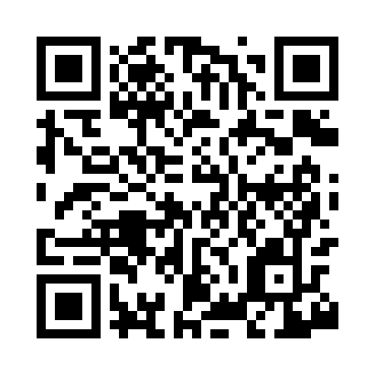
Prayer times for Yosemite Forks, California, USA
Mon 1 Jul 2024 - Wed 31 Jul 2024
High Latitude Method: Angle Based Rule
Prayer Calculation Method: Islamic Society of North America
Asar Calculation Method: Shafi

Date | Day | Fajr | Sunrise | Dhuhr | Asr | Maghrib | Isha
1 | Mon | 4:12 | 5:42 | 1:03 | 4:55 | 8:23 | 9:53
2 | Tue | 4:12 | 5:42 | 1:03 | 4:55 | 8:23 | 9:53
3 | Wed | 4:13 | 5:43 | 1:03 | 4:56 | 8:23 | 9:53
4 | Thu | 4:14 | 5:43 | 1:03 | 4:56 | 8:23 | 9:52
5 | Fri | 4:14 | 5:44 | 1:03 | 4:56 | 8:22 | 9:52
6 | Sat | 4:15 | 5:45 | 1:03 | 4:56 | 8:22 | 9:52
7 | Sun | 4:16 | 5:45 | 1:04 | 4:56 | 8:22 | 9:51
8 | Mon | 4:17 | 5:46 | 1:04 | 4:56 | 8:22 | 9:51
9 | Tue | 4:17 | 5:46 | 1:04 | 4:56 | 8:21 | 9:50
10 | Wed | 4:18 | 5:47 | 1:04 | 4:56 | 8:21 | 9:49
11 | Thu | 4:19 | 5:48 | 1:04 | 4:56 | 8:21 | 9:49
12 | Fri | 4:20 | 5:48 | 1:04 | 4:56 | 8:20 | 9:48
13 | Sat | 4:21 | 5:49 | 1:04 | 4:56 | 8:20 | 9:47
14 | Sun | 4:22 | 5:50 | 1:05 | 4:56 | 8:19 | 9:47
15 | Mon | 4:23 | 5:50 | 1:05 | 4:56 | 8:19 | 9:46
16 | Tue | 4:24 | 5:51 | 1:05 | 4:56 | 8:18 | 9:45
17 | Wed | 4:25 | 5:52 | 1:05 | 4:56 | 8:18 | 9:44
18 | Thu | 4:26 | 5:52 | 1:05 | 4:56 | 8:17 | 9:43
19 | Fri | 4:27 | 5:53 | 1:05 | 4:56 | 8:16 | 9:43
20 | Sat | 4:28 | 5:54 | 1:05 | 4:56 | 8:16 | 9:42
21 | Sun | 4:29 | 5:55 | 1:05 | 4:56 | 8:15 | 9:41
22 | Mon | 4:30 | 5:55 | 1:05 | 4:56 | 8:14 | 9:40
23 | Tue | 4:31 | 5:56 | 1:05 | 4:56 | 8:13 | 9:39
24 | Wed | 4:32 | 5:57 | 1:05 | 4:56 | 8:13 | 9:37
25 | Thu | 4:33 | 5:58 | 1:05 | 4:56 | 8:12 | 9:36
26 | Fri | 4:34 | 5:59 | 1:05 | 4:56 | 8:11 | 9:35
27 | Sat | 4:35 | 5:59 | 1:05 | 4:55 | 8:10 | 9:34
28 | Sun | 4:36 | 6:00 | 1:05 | 4:55 | 8:09 | 9:33
29 | Mon | 4:38 | 6:01 | 1:05 | 4:55 | 8:08 | 9:32
30 | Tue | 4:39 | 6:02 | 1:05 | 4:55 | 8:08 | 9:31
31 | Wed | 4:40 | 6:03 | 1:05 | 4:54 | 8:07 | 9:29
Prayer times provided by https://www.salahtimes.com

