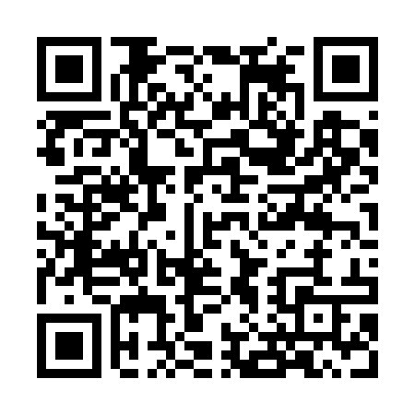
Prayer times for Albisola Marina, Italy
Wed 1 May 2024 - Fri 31 May 2024
High Latitude Method: Angle Based Rule
Prayer Calculation Method: Muslim World League
Asar Calculation Method: Hanafi

Date | Day | Fajr | Sunrise | Dhuhr | Asr | Maghrib | Isha
1 | Wed | 4:21 | 6:16 | 1:23 | 6:23 | 8:30 | 10:18
2 | Thu | 4:19 | 6:15 | 1:23 | 6:23 | 8:32 | 10:20
3 | Fri | 4:17 | 6:13 | 1:23 | 6:24 | 8:33 | 10:22
4 | Sat | 4:15 | 6:12 | 1:23 | 6:25 | 8:34 | 10:24
5 | Sun | 4:13 | 6:11 | 1:23 | 6:25 | 8:35 | 10:26
6 | Mon | 4:10 | 6:09 | 1:23 | 6:26 | 8:36 | 10:28
7 | Tue | 4:08 | 6:08 | 1:22 | 6:27 | 8:38 | 10:29
8 | Wed | 4:06 | 6:07 | 1:22 | 6:27 | 8:39 | 10:31
9 | Thu | 4:04 | 6:06 | 1:22 | 6:28 | 8:40 | 10:33
10 | Fri | 4:02 | 6:04 | 1:22 | 6:29 | 8:41 | 10:35
11 | Sat | 4:00 | 6:03 | 1:22 | 6:30 | 8:42 | 10:37
12 | Sun | 3:58 | 6:02 | 1:22 | 6:30 | 8:43 | 10:39
13 | Mon | 3:56 | 6:01 | 1:22 | 6:31 | 8:44 | 10:40
14 | Tue | 3:54 | 6:00 | 1:22 | 6:32 | 8:46 | 10:42
15 | Wed | 3:53 | 5:59 | 1:22 | 6:32 | 8:47 | 10:44
16 | Thu | 3:51 | 5:57 | 1:22 | 6:33 | 8:48 | 10:46
17 | Fri | 3:49 | 5:56 | 1:22 | 6:33 | 8:49 | 10:48
18 | Sat | 3:47 | 5:55 | 1:22 | 6:34 | 8:50 | 10:49
19 | Sun | 3:45 | 5:54 | 1:22 | 6:35 | 8:51 | 10:51
20 | Mon | 3:43 | 5:53 | 1:23 | 6:35 | 8:52 | 10:53
21 | Tue | 3:42 | 5:53 | 1:23 | 6:36 | 8:53 | 10:55
22 | Wed | 3:40 | 5:52 | 1:23 | 6:37 | 8:54 | 10:57
23 | Thu | 3:38 | 5:51 | 1:23 | 6:37 | 8:55 | 10:58
24 | Fri | 3:37 | 5:50 | 1:23 | 6:38 | 8:56 | 11:00
25 | Sat | 3:35 | 5:49 | 1:23 | 6:38 | 8:57 | 11:02
26 | Sun | 3:33 | 5:48 | 1:23 | 6:39 | 8:58 | 11:03
27 | Mon | 3:32 | 5:48 | 1:23 | 6:39 | 8:59 | 11:05
28 | Tue | 3:30 | 5:47 | 1:23 | 6:40 | 9:00 | 11:06
29 | Wed | 3:29 | 5:46 | 1:23 | 6:41 | 9:01 | 11:08
30 | Thu | 3:28 | 5:46 | 1:24 | 6:41 | 9:02 | 11:09
31 | Fri | 3:26 | 5:45 | 1:24 | 6:42 | 9:03 | 11:11
Prayer times provided by https://www.salahtimes.com

