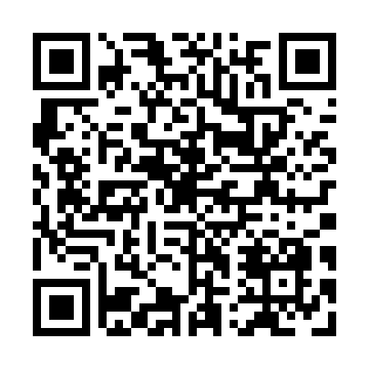
Prayer times for Kaupashkueiat, Quebec, Canada
Mon 1 Jul 2024 - Wed 31 Jul 2024
High Latitude Method: Angle Based Rule
Prayer Calculation Method: Islamic Society of North America
Asar Calculation Method: Hanafi

Date | Day | Fajr | Sunrise | Dhuhr | Asr | Maghrib | Isha
1 | Mon | 2:33 | 4:26 | 12:40 | 6:15 | 8:55 | 10:47
2 | Tue | 2:33 | 4:26 | 12:40 | 6:15 | 8:54 | 10:47
3 | Wed | 2:34 | 4:27 | 12:41 | 6:15 | 8:54 | 10:47
4 | Thu | 2:34 | 4:28 | 12:41 | 6:15 | 8:53 | 10:47
5 | Fri | 2:35 | 4:29 | 12:41 | 6:15 | 8:53 | 10:47
6 | Sat | 2:35 | 4:30 | 12:41 | 6:15 | 8:52 | 10:47
7 | Sun | 2:36 | 4:30 | 12:41 | 6:14 | 8:52 | 10:46
8 | Mon | 2:36 | 4:31 | 12:41 | 6:14 | 8:51 | 10:46
9 | Tue | 2:37 | 4:32 | 12:42 | 6:14 | 8:50 | 10:46
10 | Wed | 2:37 | 4:33 | 12:42 | 6:13 | 8:49 | 10:45
11 | Thu | 2:38 | 4:34 | 12:42 | 6:13 | 8:49 | 10:45
12 | Fri | 2:39 | 4:36 | 12:42 | 6:13 | 8:48 | 10:45
13 | Sat | 2:39 | 4:37 | 12:42 | 6:12 | 8:47 | 10:44
14 | Sun | 2:40 | 4:38 | 12:42 | 6:12 | 8:46 | 10:44
15 | Mon | 2:40 | 4:39 | 12:42 | 6:11 | 8:45 | 10:43
16 | Tue | 2:41 | 4:40 | 12:42 | 6:11 | 8:44 | 10:43
17 | Wed | 2:42 | 4:41 | 12:42 | 6:10 | 8:43 | 10:42
18 | Thu | 2:42 | 4:43 | 12:42 | 6:10 | 8:42 | 10:42
19 | Fri | 2:43 | 4:44 | 12:43 | 6:09 | 8:41 | 10:41
20 | Sat | 2:44 | 4:45 | 12:43 | 6:08 | 8:39 | 10:41
21 | Sun | 2:44 | 4:47 | 12:43 | 6:08 | 8:38 | 10:40
22 | Mon | 2:45 | 4:48 | 12:43 | 6:07 | 8:37 | 10:40
23 | Tue | 2:46 | 4:49 | 12:43 | 6:06 | 8:35 | 10:39
24 | Wed | 2:46 | 4:51 | 12:43 | 6:05 | 8:34 | 10:38
25 | Thu | 2:47 | 4:52 | 12:43 | 6:05 | 8:33 | 10:38
26 | Fri | 2:48 | 4:53 | 12:43 | 6:04 | 8:31 | 10:37
27 | Sat | 2:49 | 4:55 | 12:43 | 6:03 | 8:30 | 10:36
28 | Sun | 2:49 | 4:56 | 12:43 | 6:02 | 8:28 | 10:35
29 | Mon | 2:50 | 4:58 | 12:43 | 6:01 | 8:27 | 10:35
30 | Tue | 2:51 | 4:59 | 12:43 | 6:00 | 8:25 | 10:33
31 | Wed | 2:54 | 5:01 | 12:43 | 5:59 | 8:24 | 10:30
Prayer times provided by https://www.salahtimes.com

