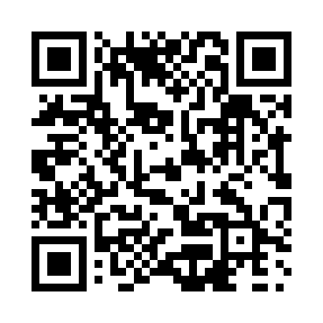
Prayer times for De Quen-Est, Quebec, Canada
Wed 1 May 2024 - Fri 31 May 2024
High Latitude Method: Angle Based Rule
Prayer Calculation Method: Islamic Society of North America
Asar Calculation Method: Hanafi

Date | Day | Fajr | Sunrise | Dhuhr | Asr | Maghrib | Isha
1 | Wed | 3:41 | 5:26 | 12:44 | 5:48 | 8:02 | 9:47
2 | Thu | 3:39 | 5:24 | 12:43 | 5:49 | 8:03 | 9:50
3 | Fri | 3:36 | 5:23 | 12:43 | 5:50 | 8:05 | 9:52
4 | Sat | 3:34 | 5:21 | 12:43 | 5:50 | 8:06 | 9:54
5 | Sun | 3:31 | 5:19 | 12:43 | 5:51 | 8:08 | 9:56
6 | Mon | 3:29 | 5:18 | 12:43 | 5:52 | 8:09 | 9:58
7 | Tue | 3:27 | 5:16 | 12:43 | 5:53 | 8:11 | 10:01
8 | Wed | 3:24 | 5:15 | 12:43 | 5:54 | 8:12 | 10:03
9 | Thu | 3:22 | 5:13 | 12:43 | 5:55 | 8:13 | 10:05
10 | Fri | 3:20 | 5:12 | 12:43 | 5:55 | 8:15 | 10:07
11 | Sat | 3:18 | 5:10 | 12:43 | 5:56 | 8:16 | 10:09
12 | Sun | 3:15 | 5:09 | 12:43 | 5:57 | 8:17 | 10:12
13 | Mon | 3:13 | 5:08 | 12:43 | 5:58 | 8:19 | 10:14
14 | Tue | 3:11 | 5:06 | 12:43 | 5:59 | 8:20 | 10:16
15 | Wed | 3:09 | 5:05 | 12:43 | 5:59 | 8:21 | 10:18
16 | Thu | 3:06 | 5:04 | 12:43 | 6:00 | 8:23 | 10:21
17 | Fri | 3:04 | 5:03 | 12:43 | 6:01 | 8:24 | 10:23
18 | Sat | 3:02 | 5:01 | 12:43 | 6:02 | 8:25 | 10:25
19 | Sun | 3:00 | 5:00 | 12:43 | 6:03 | 8:27 | 10:27
20 | Mon | 2:58 | 4:59 | 12:43 | 6:03 | 8:28 | 10:29
21 | Tue | 2:56 | 4:58 | 12:43 | 6:04 | 8:29 | 10:32
22 | Wed | 2:54 | 4:57 | 12:43 | 6:05 | 8:30 | 10:34
23 | Thu | 2:52 | 4:56 | 12:43 | 6:05 | 8:31 | 10:36
24 | Fri | 2:50 | 4:55 | 12:43 | 6:06 | 8:33 | 10:38
25 | Sat | 2:49 | 4:54 | 12:44 | 6:07 | 8:34 | 10:39
26 | Sun | 2:48 | 4:53 | 12:44 | 6:07 | 8:35 | 10:39
27 | Mon | 2:48 | 4:52 | 12:44 | 6:08 | 8:36 | 10:40
28 | Tue | 2:48 | 4:51 | 12:44 | 6:09 | 8:37 | 10:41
29 | Wed | 2:47 | 4:51 | 12:44 | 6:09 | 8:38 | 10:41
30 | Thu | 2:47 | 4:50 | 12:44 | 6:10 | 8:39 | 10:42
31 | Fri | 2:47 | 4:49 | 12:44 | 6:11 | 8:40 | 10:42
Prayer times provided by https://www.salahtimes.com

