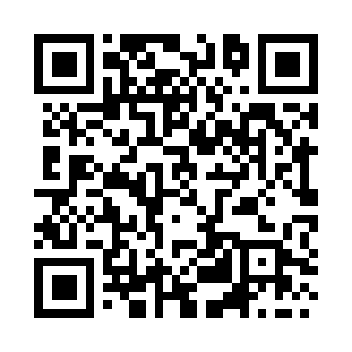

**Prayer times for Brokkebjerg, Denmark**

**Sun 1 Sep 2024 - Mon 30 Sep 2024**

**High Latitude Method: Angle Based Rule**

**Prayer Calculation Method: Muslim World League**

**Asar Calculation Method: Hanafi**

|  |  |  |  |  |  |  |  |
| --- | --- | --- | --- | --- | --- | --- | --- |
| **Date** | **Day** | **Fajr** | **Sunrise** | **Dhuhr** | **Asr** | **Maghrib** | **Isha** |
| 1 | Sun | 3:57 | 6:21 | 1:15 | 5:55 | 8:09 | 10:22 |
| 2 | Mon | 4:00 | 6:23 | 1:15 | 5:53 | 8:06 | 10:19 |
| 3 | Tue | 4:03 | 6:25 | 1:15 | 5:51 | 8:03 | 10:15 |
| 4 | Wed | 4:06 | 6:27 | 1:14 | 5:49 | 8:01 | 10:11 |
| 5 | Thu | 4:09 | 6:29 | 1:14 | 5:47 | 7:58 | 10:08 |
| 6 | Fri | 4:12 | 6:31 | 1:14 | 5:45 | 7:56 | 10:04 |
| 7 | Sat | 4:15 | 6:33 | 1:13 | 5:43 | 7:53 | 10:01 |
| 8 | Sun | 4:18 | 6:35 | 1:13 | 5:41 | 7:50 | 9:57 |
| 9 | Mon | 4:21 | 6:37 | 1:13 | 5:39 | 7:48 | 9:54 |
| 10 | Tue | 4:23 | 6:39 | 1:12 | 5:36 | 7:45 | 9:51 |
| 11 | Wed | 4:26 | 6:40 | 1:12 | 5:34 | 7:43 | 9:47 |
| 12 | Thu | 4:29 | 6:42 | 1:12 | 5:32 | 7:40 | 9:44 |
| 13 | Fri | 4:32 | 6:44 | 1:11 | 5:30 | 7:37 | 9:41 |
| 14 | Sat | 4:34 | 6:46 | 1:11 | 5:28 | 7:35 | 9:38 |
| 15 | Sun | 4:37 | 6:48 | 1:11 | 5:26 | 7:32 | 9:34 |
| 16 | Mon | 4:39 | 6:50 | 1:10 | 5:24 | 7:29 | 9:31 |
| 17 | Tue | 4:42 | 6:52 | 1:10 | 5:21 | 7:27 | 9:28 |
| 18 | Wed | 4:44 | 6:54 | 1:10 | 5:19 | 7:24 | 9:25 |
| 19 | Thu | 4:47 | 6:56 | 1:09 | 5:17 | 7:21 | 9:22 |
| 20 | Fri | 4:49 | 6:58 | 1:09 | 5:15 | 7:19 | 9:19 |
| 21 | Sat | 4:52 | 7:00 | 1:08 | 5:12 | 7:16 | 9:16 |
| 22 | Sun | 4:54 | 7:02 | 1:08 | 5:10 | 7:14 | 9:13 |
| 23 | Mon | 4:57 | 7:04 | 1:08 | 5:08 | 7:11 | 9:10 |
| 24 | Tue | 4:59 | 7:05 | 1:07 | 5:06 | 7:08 | 9:07 |
| 25 | Wed | 5:01 | 7:07 | 1:07 | 5:04 | 7:06 | 9:04 |
| 26 | Thu | 5:04 | 7:09 | 1:07 | 5:01 | 7:03 | 9:01 |
| 27 | Fri | 5:06 | 7:11 | 1:06 | 4:59 | 7:00 | 8:58 |
| 28 | Sat | 5:08 | 7:13 | 1:06 | 4:57 | 6:58 | 8:55 |
| 29 | Sun | 5:10 | 7:15 | 1:06 | 4:54 | 6:55 | 8:52 |
| 30 | Mon | 5:13 | 7:17 | 1:05 | 4:52 | 6:53 | 8:49 |

**Prayer times provided by https://www.salahtimes.com**