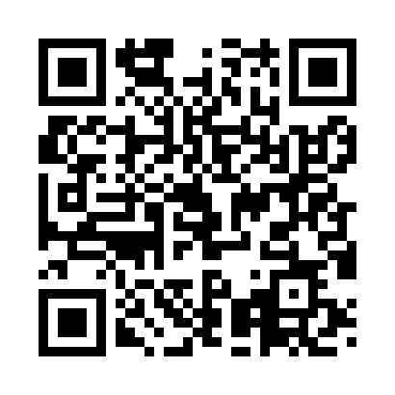
Prayer times for Artogna Campo, Italy
Wed 1 May 2024 - Fri 31 May 2024
High Latitude Method: Angle Based Rule
Prayer Calculation Method: Muslim World League
Asar Calculation Method: Hanafi

Date | Day | Fajr | Sunrise | Dhuhr | Asr | Maghrib | Isha
1 | Wed | 4:15 | 6:15 | 1:25 | 6:26 | 8:36 | 10:29
2 | Thu | 4:12 | 6:14 | 1:25 | 6:27 | 8:37 | 10:31
3 | Fri | 4:10 | 6:12 | 1:25 | 6:28 | 8:39 | 10:33
4 | Sat | 4:08 | 6:11 | 1:25 | 6:29 | 8:40 | 10:35
5 | Sun | 4:06 | 6:09 | 1:25 | 6:29 | 8:41 | 10:37
6 | Mon | 4:03 | 6:08 | 1:25 | 6:30 | 8:42 | 10:39
7 | Tue | 4:01 | 6:06 | 1:25 | 6:31 | 8:44 | 10:41
8 | Wed | 3:59 | 6:05 | 1:25 | 6:32 | 8:45 | 10:43
9 | Thu | 3:57 | 6:04 | 1:25 | 6:32 | 8:46 | 10:45
10 | Fri | 3:54 | 6:02 | 1:25 | 6:33 | 8:47 | 10:47
11 | Sat | 3:52 | 6:01 | 1:25 | 6:34 | 8:49 | 10:49
12 | Sun | 3:50 | 6:00 | 1:25 | 6:34 | 8:50 | 10:51
13 | Mon | 3:48 | 5:59 | 1:25 | 6:35 | 8:51 | 10:53
14 | Tue | 3:46 | 5:57 | 1:25 | 6:36 | 8:52 | 10:55
15 | Wed | 3:43 | 5:56 | 1:25 | 6:37 | 8:53 | 10:57
16 | Thu | 3:41 | 5:55 | 1:25 | 6:37 | 8:55 | 10:59
17 | Fri | 3:39 | 5:54 | 1:25 | 6:38 | 8:56 | 11:01
18 | Sat | 3:37 | 5:53 | 1:25 | 6:39 | 8:57 | 11:03
19 | Sun | 3:35 | 5:52 | 1:25 | 6:39 | 8:58 | 11:05
20 | Mon | 3:33 | 5:51 | 1:25 | 6:40 | 8:59 | 11:07
21 | Tue | 3:31 | 5:50 | 1:25 | 6:41 | 9:00 | 11:09
22 | Wed | 3:29 | 5:49 | 1:25 | 6:41 | 9:01 | 11:11
23 | Thu | 3:27 | 5:48 | 1:25 | 6:42 | 9:02 | 11:13
24 | Fri | 3:25 | 5:47 | 1:25 | 6:43 | 9:03 | 11:15
25 | Sat | 3:23 | 5:46 | 1:25 | 6:43 | 9:04 | 11:17
26 | Sun | 3:22 | 5:46 | 1:25 | 6:44 | 9:05 | 11:18
27 | Mon | 3:20 | 5:45 | 1:25 | 6:44 | 9:06 | 11:20
28 | Tue | 3:18 | 5:44 | 1:26 | 6:45 | 9:07 | 11:22
29 | Wed | 3:16 | 5:43 | 1:26 | 6:46 | 9:08 | 11:24
30 | Thu | 3:15 | 5:43 | 1:26 | 6:46 | 9:09 | 11:26
31 | Fri | 3:13 | 5:42 | 1:26 | 6:47 | 9:10 | 11:27
Prayer times provided by https://www.salahtimes.com

