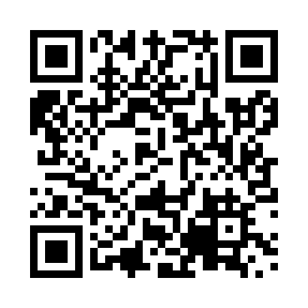
Prayer times for Kegaska, Quebec, Canada
Mon 1 Jul 2024 - Wed 31 Jul 2024
High Latitude Method: Angle Based Rule
Prayer Calculation Method: Islamic Society of North America
Asar Calculation Method: Hanafi

Date | Day | Fajr | Sunrise | Dhuhr | Asr | Maghrib | Isha
1 | Mon | 2:04 | 4:00 | 12:09 | 5:42 | 8:18 | 10:14
2 | Tue | 2:05 | 4:00 | 12:09 | 5:42 | 8:18 | 10:14
3 | Wed | 2:05 | 4:01 | 12:09 | 5:42 | 8:18 | 10:13
4 | Thu | 2:06 | 4:02 | 12:10 | 5:42 | 8:17 | 10:13
5 | Fri | 2:06 | 4:03 | 12:10 | 5:42 | 8:17 | 10:13
6 | Sat | 2:07 | 4:04 | 12:10 | 5:41 | 8:16 | 10:13
7 | Sun | 2:07 | 4:04 | 12:10 | 5:41 | 8:16 | 10:13
8 | Mon | 2:08 | 4:05 | 12:10 | 5:41 | 8:15 | 10:13
9 | Tue | 2:08 | 4:06 | 12:10 | 5:41 | 8:14 | 10:12
10 | Wed | 2:09 | 4:07 | 12:11 | 5:40 | 8:14 | 10:12
11 | Thu | 2:09 | 4:08 | 12:11 | 5:40 | 8:13 | 10:12
12 | Fri | 2:10 | 4:09 | 12:11 | 5:40 | 8:12 | 10:11
13 | Sat | 2:11 | 4:10 | 12:11 | 5:39 | 8:11 | 10:11
14 | Sun | 2:11 | 4:11 | 12:11 | 5:39 | 8:10 | 10:10
15 | Mon | 2:12 | 4:13 | 12:11 | 5:38 | 8:09 | 10:10
16 | Tue | 2:12 | 4:14 | 12:11 | 5:38 | 8:08 | 10:10
17 | Wed | 2:13 | 4:15 | 12:11 | 5:37 | 8:07 | 10:09
18 | Thu | 2:14 | 4:16 | 12:11 | 5:37 | 8:06 | 10:09
19 | Fri | 2:14 | 4:17 | 12:11 | 5:36 | 8:05 | 10:08
20 | Sat | 2:15 | 4:19 | 12:12 | 5:35 | 8:04 | 10:08
21 | Sun | 2:16 | 4:20 | 12:12 | 5:35 | 8:03 | 10:07
22 | Mon | 2:16 | 4:21 | 12:12 | 5:34 | 8:02 | 10:06
23 | Tue | 2:17 | 4:22 | 12:12 | 5:33 | 8:00 | 10:06
24 | Wed | 2:17 | 4:24 | 12:12 | 5:33 | 7:59 | 10:05
25 | Thu | 2:18 | 4:25 | 12:12 | 5:32 | 7:58 | 10:04
26 | Fri | 2:20 | 4:26 | 12:12 | 5:31 | 7:56 | 10:02
27 | Sat | 2:22 | 4:28 | 12:12 | 5:30 | 7:55 | 10:00
28 | Sun | 2:25 | 4:29 | 12:12 | 5:29 | 7:53 | 9:57
29 | Mon | 2:27 | 4:30 | 12:12 | 5:29 | 7:52 | 9:54
30 | Tue | 2:30 | 4:32 | 12:12 | 5:28 | 7:50 | 9:52
31 | Wed | 2:32 | 4:33 | 12:11 | 5:27 | 7:49 | 9:49
Prayer times provided by https://www.salahtimes.com

