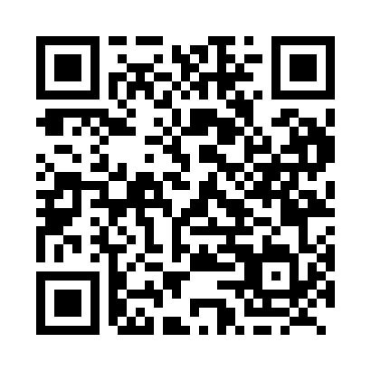
Prayer times for Fort Selkirk, Yukon, Canada
Wed 1 May 2024 - Fri 31 May 2024
High Latitude Method: Angle Based Rule
Prayer Calculation Method: Islamic Society of North America
Asar Calculation Method: Hanafi

Date | Day | Fajr | Sunrise | Dhuhr | Asr | Maghrib | Isha
1 | Wed | 3:58 | 5:49 | 2:07 | 7:29 | 10:26 | 12:17
2 | Thu | 3:56 | 5:45 | 2:06 | 7:31 | 10:29 | 12:18
3 | Fri | 3:55 | 5:42 | 2:06 | 7:32 | 10:32 | 12:20
4 | Sat | 3:53 | 5:39 | 2:06 | 7:34 | 10:35 | 12:21
5 | Sun | 3:51 | 5:36 | 2:06 | 7:36 | 10:38 | 12:22
6 | Mon | 3:50 | 5:33 | 2:06 | 7:37 | 10:41 | 12:24
7 | Tue | 3:48 | 5:30 | 2:06 | 7:39 | 10:44 | 12:25
8 | Wed | 3:47 | 5:27 | 2:06 | 7:40 | 10:47 | 12:27
9 | Thu | 3:45 | 5:24 | 2:06 | 7:42 | 10:50 | 12:28
10 | Fri | 3:44 | 5:21 | 2:06 | 7:43 | 10:52 | 12:30
11 | Sat | 3:42 | 5:18 | 2:06 | 7:45 | 10:55 | 12:31
12 | Sun | 3:41 | 5:15 | 2:06 | 7:46 | 10:58 | 12:32
13 | Mon | 3:39 | 5:12 | 2:06 | 7:48 | 11:01 | 12:34
14 | Tue | 3:38 | 5:09 | 2:06 | 7:49 | 11:04 | 12:35
15 | Wed | 3:36 | 5:06 | 2:06 | 7:50 | 11:07 | 12:37
16 | Thu | 3:35 | 5:03 | 2:06 | 7:52 | 11:10 | 12:38
17 | Fri | 3:34 | 5:01 | 2:06 | 7:53 | 11:13 | 12:40
18 | Sat | 3:32 | 4:58 | 2:06 | 7:55 | 11:15 | 12:41
19 | Sun | 3:31 | 4:55 | 2:06 | 7:56 | 11:18 | 12:43
20 | Mon | 3:30 | 4:53 | 2:06 | 7:57 | 11:21 | 12:44
21 | Tue | 3:28 | 4:50 | 2:06 | 7:58 | 11:24 | 12:45
22 | Wed | 3:27 | 4:47 | 2:06 | 8:00 | 11:27 | 12:47
23 | Thu | 3:26 | 4:45 | 2:06 | 8:01 | 11:29 | 12:48
24 | Fri | 3:25 | 4:42 | 2:06 | 8:02 | 11:32 | 12:50
25 | Sat | 3:24 | 4:40 | 2:07 | 8:03 | 11:35 | 12:51
26 | Sun | 3:22 | 4:38 | 2:07 | 8:04 | 11:37 | 12:52
27 | Mon | 3:21 | 4:35 | 2:07 | 8:06 | 11:40 | 12:54
28 | Tue | 3:20 | 4:33 | 2:07 | 8:07 | 11:42 | 12:55
29 | Wed | 3:19 | 4:31 | 2:07 | 8:08 | 11:45 | 12:56
30 | Thu | 3:18 | 4:29 | 2:07 | 8:09 | 11:47 | 12:57
31 | Fri | 3:17 | 4:27 | 2:07 | 8:10 | 11:49 | 12:59
Prayer times provided by https://www.salahtimes.com

