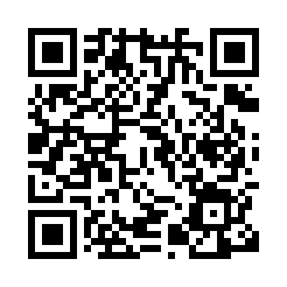

**Prayer times for Absen, Germany**

**Sun 1 Sep 2024 - Mon 30 Sep 2024**

**High Latitude Method: Angle Based Rule**

**Prayer Calculation Method: Muslim World League**

**Asar Calculation Method: Shafi**

|  |  |  |  |  |  |  |  |
| --- | --- | --- | --- | --- | --- | --- | --- |
| **Date** | **Day** | **Fajr** | **Sunrise** | **Dhuhr** | **Asr** | **Maghrib** | **Isha** |
| 1 | Sun | 4:23 | 6:36 | 1:26 | 5:09 | 8:15 | 10:18 |
| 2 | Mon | 4:26 | 6:38 | 1:26 | 5:07 | 8:12 | 10:15 |
| 3 | Tue | 4:29 | 6:40 | 1:25 | 5:06 | 8:10 | 10:12 |
| 4 | Wed | 4:31 | 6:41 | 1:25 | 5:04 | 8:08 | 10:09 |
| 5 | Thu | 4:34 | 6:43 | 1:25 | 5:03 | 8:05 | 10:05 |
| 6 | Fri | 4:36 | 6:45 | 1:24 | 5:01 | 8:03 | 10:02 |
| 7 | Sat | 4:39 | 6:47 | 1:24 | 4:59 | 8:00 | 9:59 |
| 8 | Sun | 4:41 | 6:48 | 1:24 | 4:58 | 7:58 | 9:56 |
| 9 | Mon | 4:44 | 6:50 | 1:23 | 4:56 | 7:56 | 9:53 |
| 10 | Tue | 4:46 | 6:52 | 1:23 | 4:55 | 7:53 | 9:50 |
| 11 | Wed | 4:49 | 6:54 | 1:23 | 4:53 | 7:51 | 9:47 |
| 12 | Thu | 4:51 | 6:55 | 1:22 | 4:51 | 7:48 | 9:44 |
| 13 | Fri | 4:53 | 6:57 | 1:22 | 4:50 | 7:46 | 9:41 |
| 14 | Sat | 4:56 | 6:59 | 1:22 | 4:48 | 7:43 | 9:38 |
| 15 | Sun | 4:58 | 7:00 | 1:21 | 4:46 | 7:41 | 9:35 |
| 16 | Mon | 5:00 | 7:02 | 1:21 | 4:45 | 7:39 | 9:33 |
| 17 | Tue | 5:02 | 7:04 | 1:21 | 4:43 | 7:36 | 9:30 |
| 18 | Wed | 5:05 | 7:06 | 1:20 | 4:41 | 7:34 | 9:27 |
| 19 | Thu | 5:07 | 7:07 | 1:20 | 4:40 | 7:31 | 9:24 |
| 20 | Fri | 5:09 | 7:09 | 1:19 | 4:38 | 7:29 | 9:21 |
| 21 | Sat | 5:11 | 7:11 | 1:19 | 4:36 | 7:26 | 9:18 |
| 22 | Sun | 5:13 | 7:13 | 1:19 | 4:34 | 7:24 | 9:16 |
| 23 | Mon | 5:15 | 7:14 | 1:18 | 4:33 | 7:21 | 9:13 |
| 24 | Tue | 5:17 | 7:16 | 1:18 | 4:31 | 7:19 | 9:10 |
| 25 | Wed | 5:19 | 7:18 | 1:18 | 4:29 | 7:16 | 9:07 |
| 26 | Thu | 5:21 | 7:20 | 1:17 | 4:27 | 7:14 | 9:05 |
| 27 | Fri | 5:23 | 7:21 | 1:17 | 4:25 | 7:12 | 9:02 |
| 28 | Sat | 5:25 | 7:23 | 1:17 | 4:24 | 7:09 | 9:00 |
| 29 | Sun | 5:27 | 7:25 | 1:16 | 4:22 | 7:07 | 8:57 |
| 30 | Mon | 5:29 | 7:27 | 1:16 | 4:20 | 7:04 | 8:54 |

**Prayer times provided by https://www.salahtimes.com**