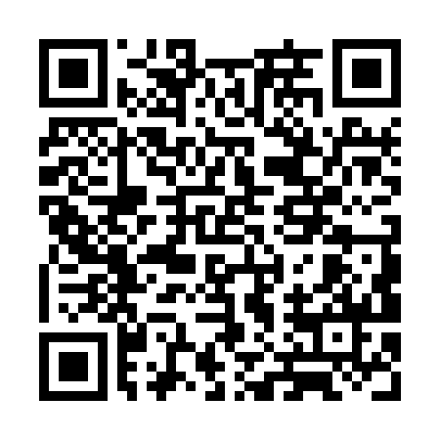
Prayer times for North Curl Curl, Australia
Mon 1 Apr 2024 - Tue 30 Apr 2024
High Latitude Method: None
Prayer Calculation Method: Muslim World League
Asar Calculation Method: Shafi

Date | Day | Fajr | Sunrise | Dhuhr | Asr | Maghrib | Isha
1 | Mon | 5:44 | 7:07 | 12:59 | 4:19 | 6:50 | 8:08
2 | Tue | 5:45 | 7:08 | 12:58 | 4:18 | 6:49 | 8:06
3 | Wed | 5:46 | 7:09 | 12:58 | 4:17 | 6:47 | 8:05
4 | Thu | 5:47 | 7:09 | 12:58 | 4:16 | 6:46 | 8:04
5 | Fri | 5:47 | 7:10 | 12:58 | 4:15 | 6:45 | 8:03
6 | Sat | 5:48 | 7:11 | 12:57 | 4:14 | 6:43 | 8:01
7 | Sun | 4:49 | 6:11 | 11:57 | 3:13 | 5:42 | 7:00
8 | Mon | 4:49 | 6:12 | 11:57 | 3:12 | 5:41 | 6:59
9 | Tue | 4:50 | 6:13 | 11:56 | 3:11 | 5:39 | 6:57
10 | Wed | 4:51 | 6:14 | 11:56 | 3:10 | 5:38 | 6:56
11 | Thu | 4:51 | 6:14 | 11:56 | 3:09 | 5:37 | 6:55
12 | Fri | 4:52 | 6:15 | 11:56 | 3:09 | 5:36 | 6:54
13 | Sat | 4:53 | 6:16 | 11:55 | 3:08 | 5:34 | 6:53
14 | Sun | 4:54 | 6:17 | 11:55 | 3:07 | 5:33 | 6:51
15 | Mon | 4:54 | 6:17 | 11:55 | 3:06 | 5:32 | 6:50
16 | Tue | 4:55 | 6:18 | 11:55 | 3:05 | 5:31 | 6:49
17 | Wed | 4:56 | 6:19 | 11:54 | 3:04 | 5:29 | 6:48
18 | Thu | 4:56 | 6:20 | 11:54 | 3:03 | 5:28 | 6:47
19 | Fri | 4:57 | 6:20 | 11:54 | 3:02 | 5:27 | 6:46
20 | Sat | 4:58 | 6:21 | 11:54 | 3:01 | 5:26 | 6:45
21 | Sun | 4:58 | 6:22 | 11:54 | 3:00 | 5:25 | 6:44
22 | Mon | 4:59 | 6:23 | 11:53 | 2:59 | 5:24 | 6:43
23 | Tue | 5:00 | 6:23 | 11:53 | 2:59 | 5:23 | 6:42
24 | Wed | 5:00 | 6:24 | 11:53 | 2:58 | 5:21 | 6:40
25 | Thu | 5:01 | 6:25 | 11:53 | 2:57 | 5:20 | 6:40
26 | Fri | 5:02 | 6:26 | 11:53 | 2:56 | 5:19 | 6:39
27 | Sat | 5:02 | 6:26 | 11:53 | 2:55 | 5:18 | 6:38
28 | Sun | 5:03 | 6:27 | 11:52 | 2:54 | 5:17 | 6:37
29 | Mon | 5:03 | 6:28 | 11:52 | 2:53 | 5:16 | 6:36
30 | Tue | 5:04 | 6:29 | 11:52 | 2:53 | 5:15 | 6:35
Prayer times provided by https://www.salahtimes.com

